21CSC202J - OPERATING SYSTEMS

LAB MANUAL

II YEAR / III Semester

FACULTY OF ENGINEERING AND TECHNOLOGY
SRM INSTITUTE OF SCIENCE AND TECHNOLOGY
RAMAPURAM CHENNAI - 600 089
LIST OF EXPERIMENTS

Ex.No. | Experiment Name
1 | A. Operating system Installation, B. Basic Linux commands, C.Filter and admin commands
2 | Process Creation using fork() and Usage of getpid(), getppid(), wait() functions
3 | Multithreading
4 | Mutual Exclusion using semaphore and monitor
5 | Reader-Writer problem
6 | Dining Philosopher problem
7 | Bankers Algorithm for Deadlock avoidance
8 | FCFS and SJF Scheduling
9 | Priority and Round robin scheduling
10 | FIFO Page Replacement Algorithm
11 | LRU and LFU Page Replacement Algorithm
12 | Best fit and Worst fit memory management policies
13 | Disk Scheduling algorithm
14 | Sequential and Indexed file Allocation
15 | File organization schemes for single level and two level directory

Academic Year: 2024-2025 ODD SEMESTER

Ex.No. 1A: Operating System Installation
Ubuntu installation guidelines in windows
Installing Ubuntu in windows 10- 64 bit
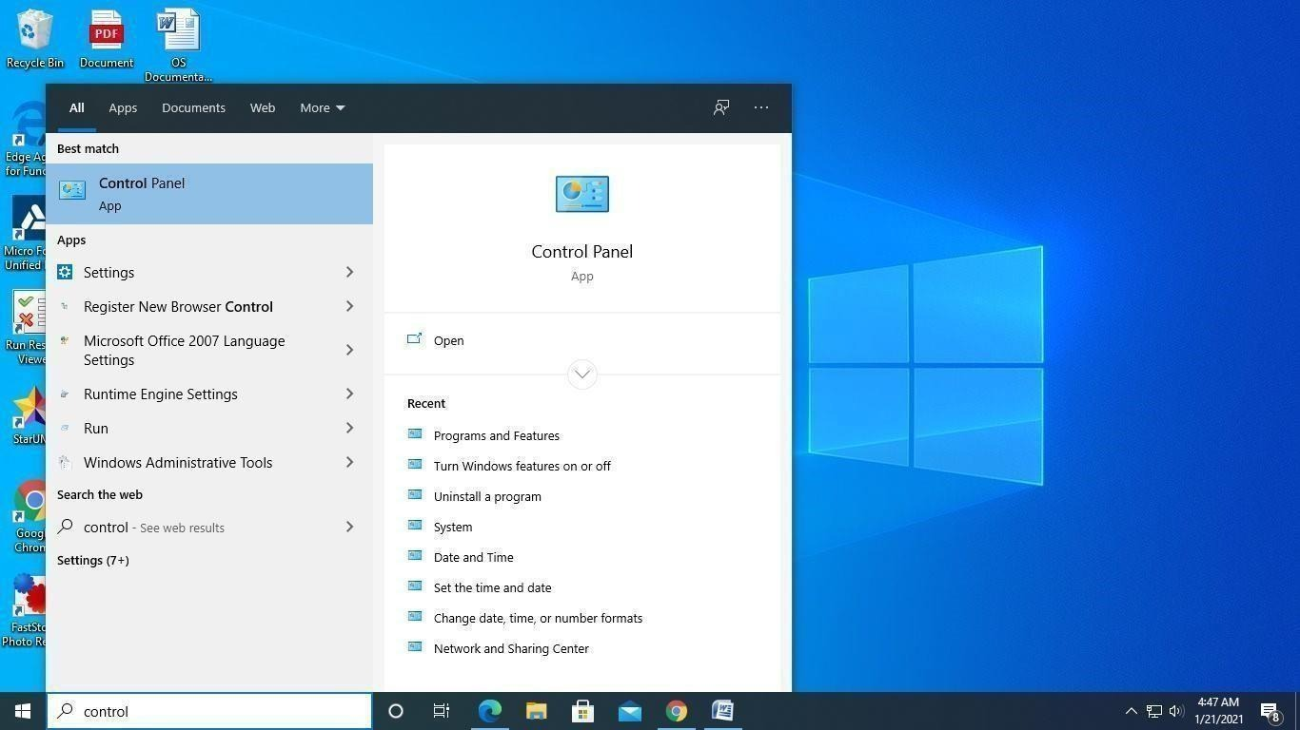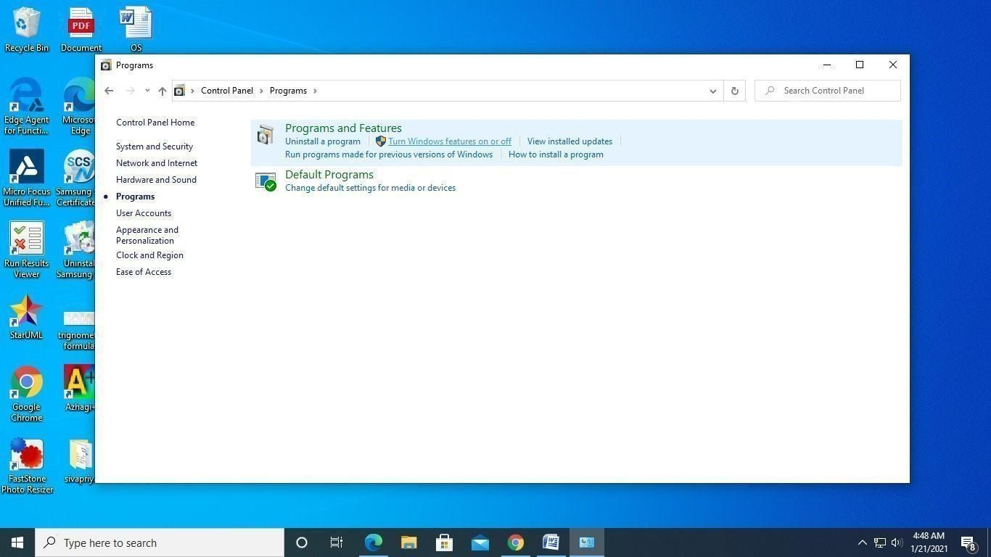
Select Turn features On or Off
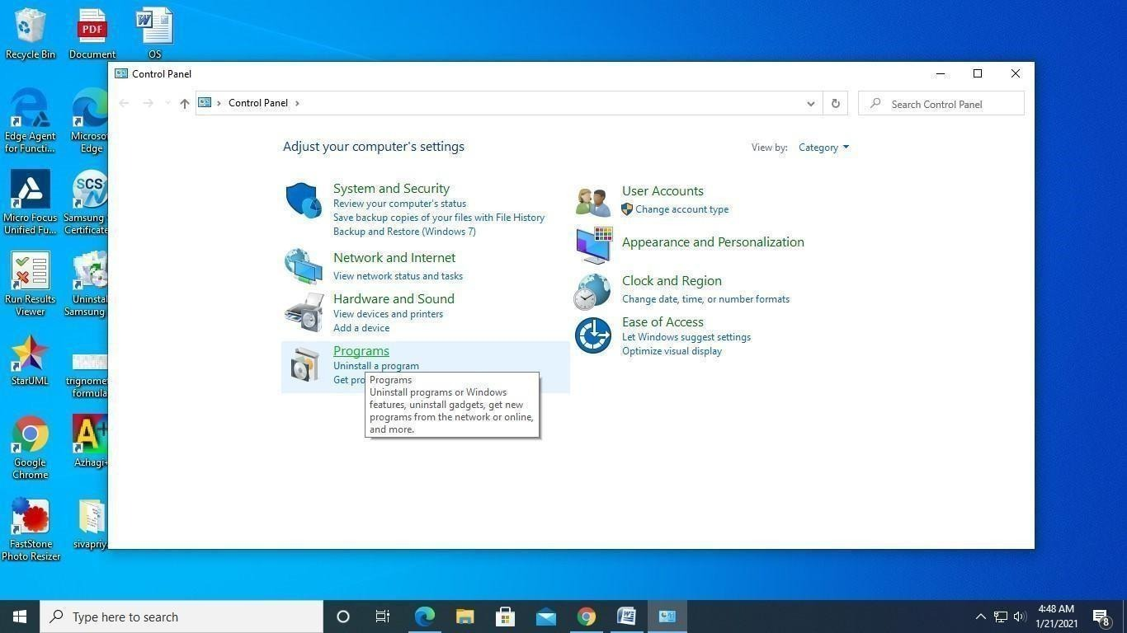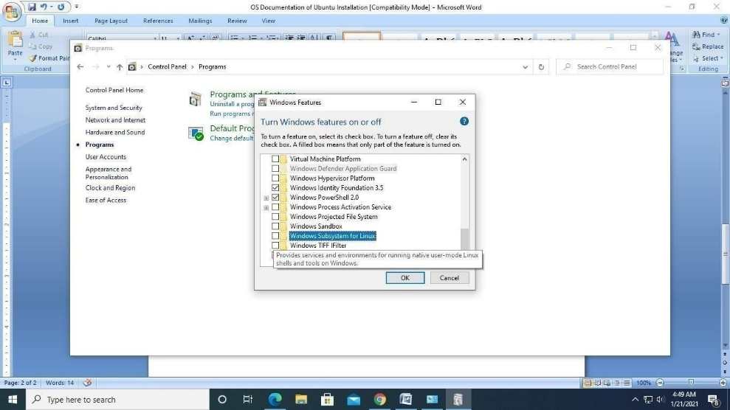
Select Windows subsystem for linux then press Ok
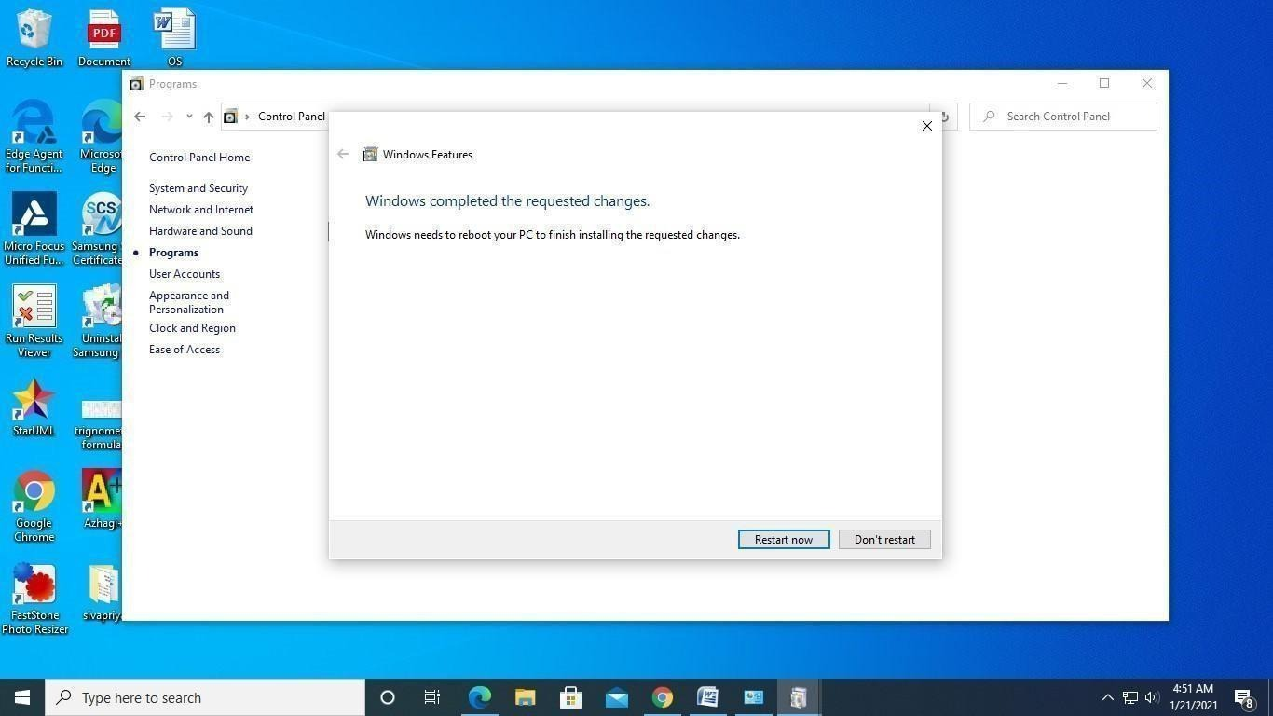
Now restart the PC to apply the changes

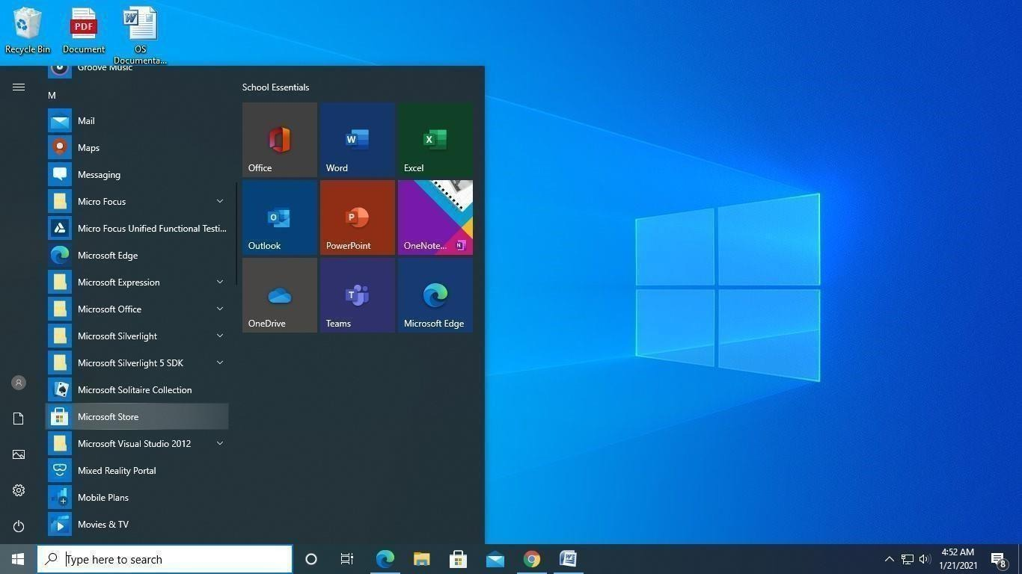Choose Microsoft Store and search for Ubuntu and

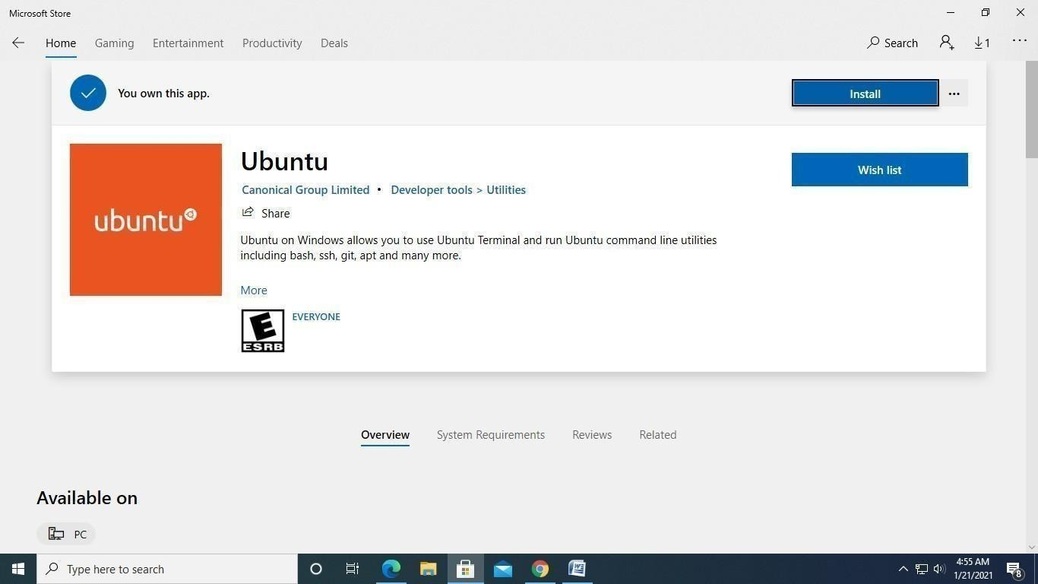
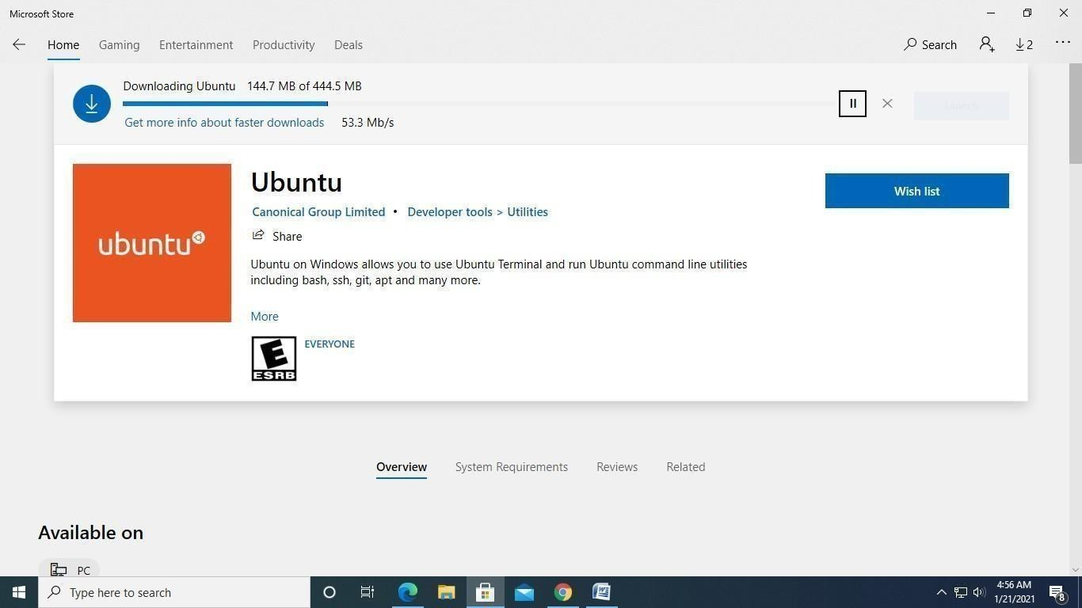Click on Install
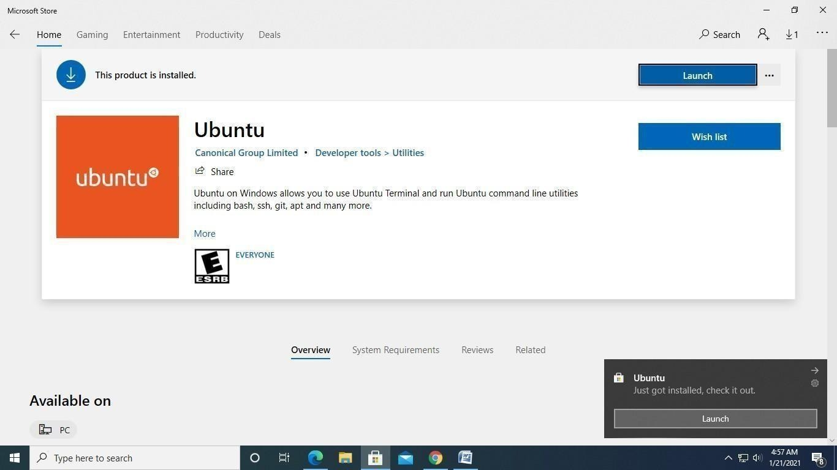
Now, Launch the Ubuntu

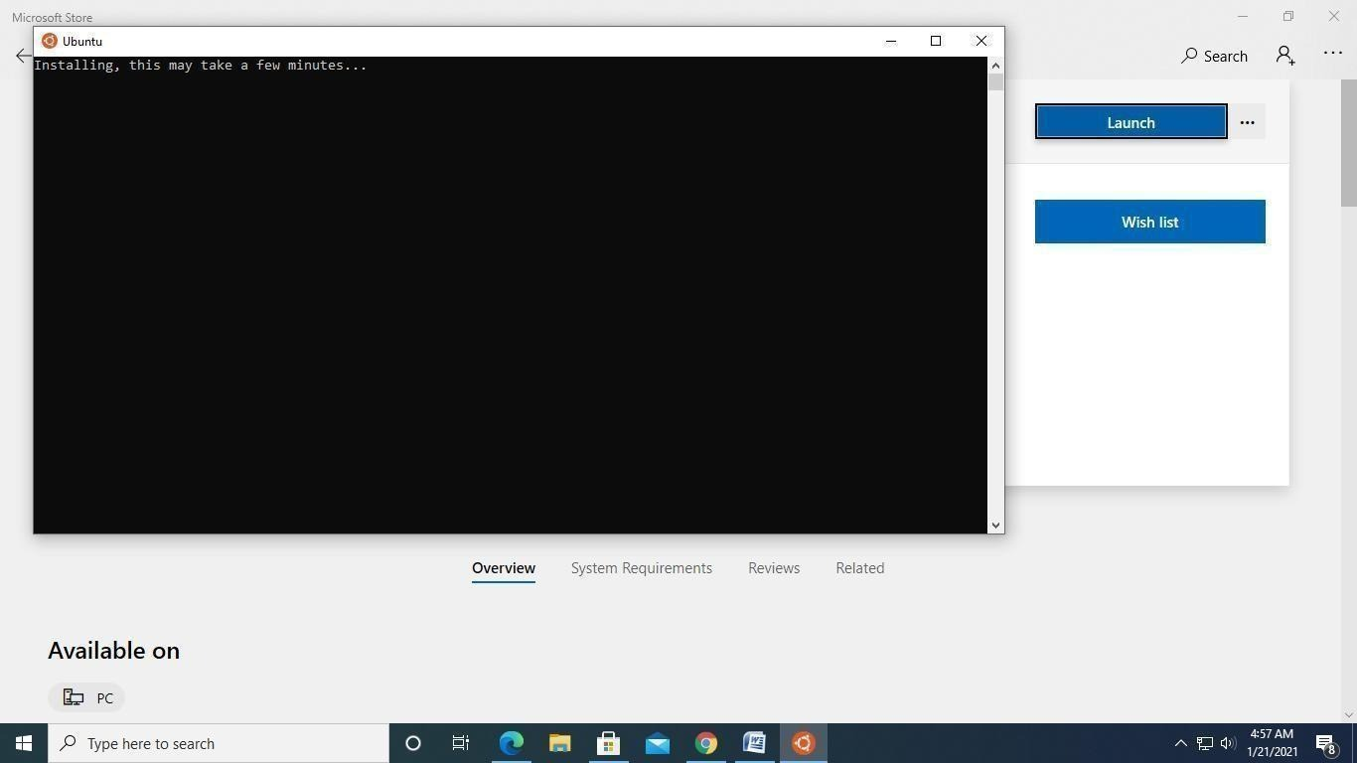*
Username: Any meaningful name
Password: Any password

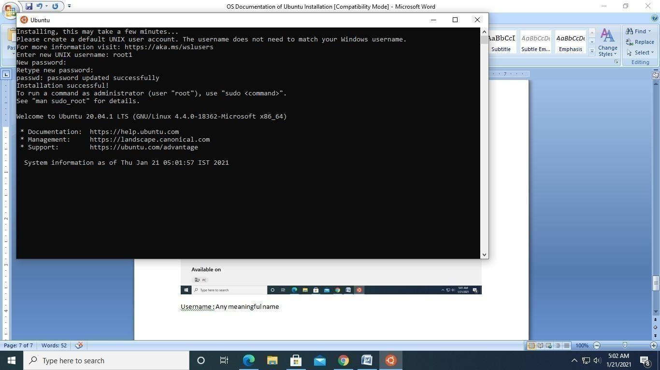*
Finally, you will get the prompt on successful installation of Ubuntu in windows 10 64 bit
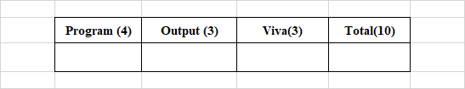
Ex.No. 1B: Basic Linux Commands
a) Basics
1. echo SRM
-> to display the string SRM
2. clear
-> to clear the screen
3. date
-> to display the current date and time
4. cal 2003
-> to display the calendar for the year 2003
cal 6 2003
-> to display the calendar for June-2003
5. passwd
-> to change password
b) Working with Files
1. ls
-> list files in the present working directory
ls -l
-> list files with detailed information (long list)
ls -a
-> list all files including the hidden files
2. cat > f1
-> to create a file (Press Ctrl+D to finish typing)
3. cat f1
-> display the content of the file f1
4. wc f1
-> list number of characters, words and lines of file f1
wc -c f1
-> list only number of characters of file f1
wc -w f1 -> list only number of words of file f1
wc -l f1 -> list only number of lines of file f1
5. cp f1 f2
-> copy file f1 into f2
6. mv f1 f2
-> rename file f1 as f2
7. rm f1
-> remove the file f1
8. head -5 f1
-> list first 5 lines of the file f1
tail -5 f1
-> list last 5 lines of the file f1
c) Working with Directories
1. mkdir elias
-> to create the directory elias
2. cd elias
-> to change the directory as elias
3. rmdir elias
-> to remove the directory elias
4. pwd
-> to display the path of the present working directory
5. cd
-> to go to the home directory
cd ..
-> to go to the parent directory
cd -
-> to go to the previous working directory
cd /
-> to go to the root directory
d) File Name Substitution
1. ls f?
-> list files starting with 'f' and followed by any one character
2. ls *.c
-> list files with extension '.c'
3. ls [gpy]et
-> list files whose first letter is any one of the characters
g, p or y and followed by the word et
4. ls [a-d,l-m]ring
-> list files whose first letter is any one of the characters
from a to d and l to m and followed by the word ring
e) I/O Redirection
1. Input redirection
wc -l < ex1
-> to find the number of lines of the file 'ex1'
2. Output redirection
who > f2
-> the output of 'who' will be redirected to file f2
3. cat >> f1
-> to append more into the file f1
f) Piping
Syntax:
Command1 | command2
Output of command1 is transferred to command2 as input.
Finally, output of command2 will be displayed on the monitor.
Example:
cat f1 | more
-> list the contents of file f1 screen by screen
head -6 f1 | tail -2
-> prints the 5th and 6th lines of the file f1
g) Environment Variables
1. echo $HOME
-> display the path of the home directory
2. echo $PS1
-> display the prompt string $
3. echo $PS2
-> display the second prompt string (> symbol by default)
4. echo $LOGNAME
-> login name
5. echo $PATH
-> list of pathname where the OS searches for an executable file
h) File Permission
chmod command is used to change the access permission of a file.
Method-1
Syntax:
chmod [ugo] [+/-] [rwxa] filename
u : user
g : group
o : others
+ : Add permission
- : Remove permission
r : read
w : write
x : execute
a : all permissions
Example:
chmod ug+rw f1
-> adding read and write permissions of file f1 to both user
and group members.
Method-2
Syntax:
chmod octnum file1
The 3 digit octal number represents as follows:
First digit -> file permissions for the user
Second digit -> file permissions for the group
Third digit -> file permissions for others
Each digit is specified as the sum of the following:
4 - read permission, 2 - write permission, 1 - execute permission
Example: chmod 754 f1
It changes the file permission for the file as follows:
- Read, write and execute permissions for the user ie. 4 + 2 + 1 = 7
- Read and execute permissions for the group members ie. 4 + 0 + 1 = 5
- Only read permission for others ie. 4 + 0 + 0 = 4
Ex.No. 1C: Filter and Admin Commands
FILTERS
1. cut
- Used to cut characters or fields from a file/input.
Syntax: cut -cchars filename
cut -ffieldnos filename
- By default, tab is the field separator (delimiter). If the fields of the files are separated by any other character, we need to specify it explicitly by using the -d option.
Syntax: cut -ddelimitchar -ffields filename
2. grep
- Used to search one or more files for a particular pattern.
Syntax: grep pattern filename(s)
- Lines that contain the pattern in the file(s) get displayed.
- Pattern can be any regular expression.
- More than one file can be searched for a pattern.
-v option displays the lines that do not contain the pattern
-l list only the names of the files that contain the pattern
-n displays the line number along with the lines that match the pattern
3. sort
- Used to sort the file in order.
Syntax: sort filename
- Sorts the data as text by default.
- Sorts by the first field by default.
-r option sorts the file in descending order
-u eliminates duplicate lines
-o filename writes sorted data into the file filename
-tdchar sorts the file in which fields are separated by dchar
-n sorts the data as numbers
+1n skips the first field and sorts the file by the second field numerically
4. Uniq
- Displays unique lines of a sorted file.
Syntax: uniq filename
-d -> option displays only the duplicate lines
-c -> displays unique lines with number of occurrences
5. diff
- Used to differentiate two files.
Syntax: diff f1 f2
compares two files f1 and f2 and prints all the lines
that are different between f1 and f2.
Q1. Write a command to cut 5 to 8 characters of the file f1.
$
Q2. Write a command to display user-id of all the users in your system.
$
Q3. Write a command to check whether the user judith is available
in your system or not. (Use grep)
$
Q4. Write a command to display the lines of the file f1
that start with SRM.
$
Q5. Write a command to sort the file /etc/passwd in descending order.
$
Q6. Write a command to display the unique lines of the sorted file f21.
Also display the number of occurrences of each line.
$
Q7. Write a command to display the lines that are common
to the files f1 and f2.
$

Ex.No. 2: Process Creation using fork() and Usage of getpid(), getppid(), wait() functions
Program 1: Process Creation using fork()
Aim C
To write a program for process creation using the fork() system call.
Algorithm
1. Start.
2. Include the header files stdio.h, sys/types.h and unistd.h.
3. In main(), call fork(). This creates a child process, so there are now 2 processes: the parent and the child.
4. Both the parent and the child continue from the statement after fork() and execute the printf() statement.
5. Each process prints "Hello World", so the message appears twice.
6. Stop.
Program
#include <stdio.h>
#include <sys/types.h>
#include <unistd.h>
int main() {
fork();
printf("Hello World\n");
return 0;
}
Compile and run: gcc p1.c -o p1 and ./p1
Definitions
fork(): A system call that creates a new process (child) by duplicating the calling process (parent). It returns 0 to the child, the child's PID to the parent, and -1 on failure.
Process: A program in execution, with its own address space, registers, and a unique process identifier (PID).
Parent and Child Process: The process that calls fork() is the parent; the new process it creates is the child. The child starts as a copy of the parent.
Header unistd.h: Provides access to POSIX system calls such as fork(), getpid() and getppid().
Header sys/types.h: Defines data types such as pid_t used for process identifiers.
Domain and Use Case
Domain: Operating Systems (Process Management) and System Programming.
Use Case: Process creation with fork() is the foundation of how Unix and Linux systems run programs. A shell creates a child process for every command typed, and web servers such as Apache and Nginx fork worker processes to handle many client requests in parallel. Understanding how repeated fork() calls multiply processes also helps developers avoid accidental fork bombs and manage system resources.
Output
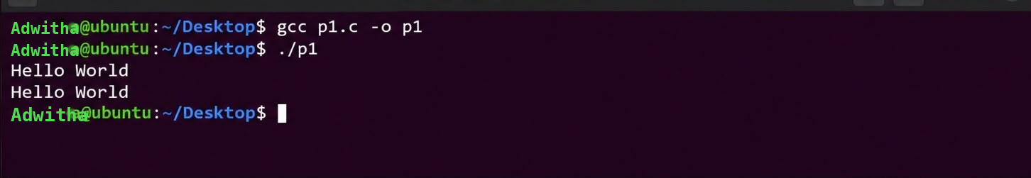

Program 2: Usage of getpid() and getppid()
Aim
To write a program that uses the getpid() and getppid() functions to display the process id of the calling process and of its parent process.
Algorithm
1. Start.
2. Include the header files stdio.h, sys/types.h and unistd.h.
3. Declare two integer variables, process_id and p_process_id.
4. Call getpid() and store the process id of the calling process in process_id.
5. Call getppid() and store the process id of the parent process in p_process_id.
6. Print the values of process_id and p_process_id.
7. Stop.
Program
#include <stdio.h>
#include <sys/types.h>
#include <unistd.h>
int main() {
/* variables to store the calling function's ids */
int process_id, p_process_id;
/* getpid() returns the process id of the calling function */
process_id = getpid();
/* getppid() returns the process id of the parent function */
p_process_id = getppid();
/* printing the process ids */
printf("The process id: %d\n", process_id);
printf("The process id of parent function: %d\n", p_process_id);
return 0;
}
Compile and run: gcc p2.c -o p2 and ./p2
Definitions
getpid(): A system call that returns the process id (PID) of the calling process.
getppid(): A system call that returns the process id of the parent of the calling process (PPID).
Process ID (PID): A unique positive integer assigned by the operating system to every running process.
pid_t: A signed integer data type, defined in sys/types.h, used to store process identifiers.
Domain and Use Case
Domain: Operating Systems (Process Identification and Monitoring) and System Administration.
Use Case: PIDs are used by tools such as ps, top and kill to monitor and control processes. Applications write their PID into log files and lock files so that administrators can find a running service, avoid starting duplicate instances, or stop it safely. The parent PID helps trace which process started another, which is useful when debugging process hierarchies.

Output
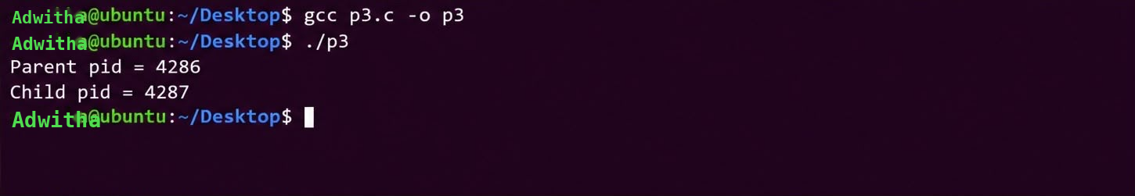

Program 3: Usage of wait()
Aim
To write a program that uses the wait() system call so that a parent process waits for its child process to terminate.
Algorithm
1. Start.
2. Include the header files stdio.h, stdlib.h, sys/types.h, sys/wait.h and unistd.h.
3. Declare a variable cpid of type pid_t.
4. Call fork() to create a child process.
5. If fork() returns 0 (child process), terminate the child using exit(0).
6. Otherwise (parent process), call wait(NULL). The parent blocks until the child terminates, reaps it, and receives the child's pid, which is stored in cpid.
7. Print the parent's process id using getpid() and the child's process id stored in cpid.
8. Return 0 and stop.
Program
#include <stdio.h>
#include <stdlib.h>
#include <sys/types.h>
#include <sys/wait.h>
#include <unistd.h>
int main() {
pid_t cpid;
if (fork() == 0)
exit(0); /* terminate child */
else
cpid = wait(NULL); /* reaping parent */
printf("Parent pid = %d\n", getpid());
printf("Child pid = %d\n", cpid);
return 0;
}
Compile and run: gcc p3.c -o p3 and ./p3
Definitions
wait(): A system call that suspends the calling (parent) process until one of its child processes terminates, and returns the pid of the terminated child.
exit(): A function that terminates the calling process and returns a status value to its parent.
Zombie Process: A terminated child process that still has an entry in the process table because its parent has not yet called wait().
Reaping: The act of the parent collecting a terminated child's exit status using wait(), which frees the child's process table entry.
Domain and Use Case
Domain: Operating Systems (Process Synchronization and Process Management).
Use Case: Parent processes use wait() to make sure child tasks have finished before continuing and to prevent zombie processes from filling the process table. A shell waits for a foreground command to complete before showing the next prompt, and a build system waits for compiler processes to finish before linking. Servers that spawn worker processes call wait() to collect exit statuses and restart failed workers.
Output
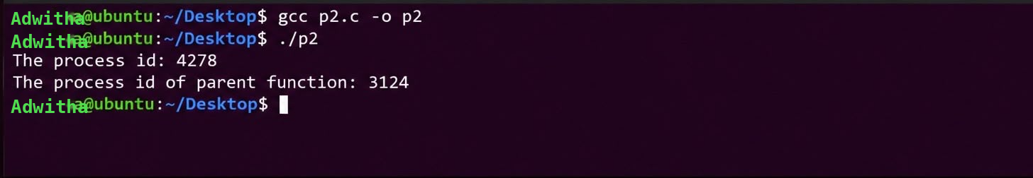

EX:NO:3 Multithreading and pthread in C
Aim: To implement and study Multithreading and pthread in C
Part A Multiprocess multithreading
Algorithm:
BEGIN
DRIVER(id)
Display "Driver id: Ride accepted"
Wait for 1 second
Display "Driver id: Trip done | Payment received"
Return
Create a child process using FORK()
IF child process is created THEN
Create two threads
FOR driver ID from 0 to 1
Create a thread to execute DRIVER(driver ID)
END FOR
Wait for both threads to finish using JOIN()
ELSE
Create another child process using FORK()
IF child process is created THEN
Create two threads
FOR driver ID from 2 to 3
Create a thread to execute DRIVER(driver ID)
END FOR
Wait for both threads to finish using JOIN()
ELSE
Wait for the first child process using WAIT()
Wait for the second child process using WAIT()
END IF
END IF
END
Program:
#include <pthread.h>
#include <stdio.h>
#include <unistd.h>
#include <sys/wait.h>
void* driver(void* id) {long d=(long)id;printf("Driver %ld: Ride accepted\n",d);sleep(1);
printf("Driver %ld: Trip done | Payment received\n",d);return NULL;}
int main() {if(fork()==0){ pthread_t t[2];
for(long i=0;i<2;i++) pthread_create(&t[i],NULL,driver,(void*)i);
for(int i=0;i<2;i++) pthread_join(t[i],NULL); }
else if(fork()==0){ pthread_t t[2];
for(long i=2;i<4;i++) pthread_create(&t[i-2],NULL,driver,(void*)i);
for(int i=0;i<2;i++) pthread_join(t[i],NULL); }
else { wait(NULL); wait(NULL); }return 0;}
Program output

Part B Single process multi threading
Algorithm
BEGIN
Define DRIVER(id)
Receive driver ID
Display "Driver id: Ride accepted"
Wait for 1 second
Display "Driver id: Ride completed"
Wait for 1 second
Display "Driver id: Payment received"
Terminate thread
Create a single process
Display "Single Process: Creating 4 threads..."
FOR i = 0 to 3
Create a thread with driver ID i
Execute DRIVER(i)
END FOR
Display "Single Process: Waiting for all threads..."

FOR i = 0 to 3
Wait for thread i to complete
END FOR
Display "Single Process: All threads finished. Program ending."
END
Program
#include <pthread.h>
#include <stdio.h>
#include <unistd.h>
void* driver(void* id) {
long d = (long)id;
printf("Driver %ld: Ride accepted\n", d);
sleep(1);
printf("Driver %ld: Ride completed\n", d);
sleep(1);
printf("Driver %ld: Payment received\n", d);
return NULL;
}
int main() {
pthread_t t[4];
printf("Single Process: Creating 4 threads...\n");
for(long i=0;i<4;i++) pthread_create(&t[i],NULL,driver,(void*)i);
printf("Single Process: Waiting for all threads...\n");
for(int i=0;i<4;i++) pthread_join(t[i],NULL);
printf("Single Process: All threads finished. Program ending.\n");
return 0;
}
Program output

Definitions:
Thread: A thread is the smallest unit of execution within a process.
It has its own program counter and execution flow but shares memory and resources with other threads of the same process.
Threads are lightweight and allow multiple tasks to run concurrently within a process.
Process: A process is a program in execution with its own address space, memory, and system resources.
A process can contain one or more threads and operates independently from other processes.
Processes provide better isolation, while communication between them generally requires inter-process communication mechanisms.
MPMT – Multi Process Multi Threading: Multiple processes are created and each process contains multiple threads.
The processes and their threads can execute concurrently, allowing several tasks to be performed at the same time.
It provides high concurrency but requires proper synchronization and resource management.

SPST – Single Process Single Threading: Only one process is created and it contains only one thread.
The program follows a single execution path, so only one task is executed at a time.
It is simple to implement but does not provide parallel execution within the process.
MPST – Multi Process Single Threading: Multiple processes are created, with each process containing only one thread.
Each process has its own memory space and can execute independently or concurrently with other processes.
This model provides process-level parallelism but does not use multiple threads within a process.
SPMT – Single Process Multi Threading: One process is created and it contains multiple threads.
All threads share the same process memory and resources while having separate execution flows.
It improves concurrency and is useful when different tasks need to be performed within the same application.
Domain and Usecase: Uber-like ride booking system
Result:
Successfully implemented and studied Multithreading and pthread in C

EX: NO: 4 Mutual Exclusion using semaphore and monitor
Aim: To implement Mutual Exclusion using semaphore and monitor
PART A : MUTUAL EXCLUSION

Algorithm:
BEGIN
Initialize 11 seats as unoccupied
Initialize a mutex
Define BOOK_SEAT(name)
Lock the mutex
Display "name seat: "
Read the seat number
IF the selected seat is unoccupied THEN
Mark the seat as occupied
Display "Booked name → seat number"
ELSE
Display "Taken!"
END IF
Unlock the mutex
Terminate thread
Create three threads
Assign the names Rahul, Priya, and Amit to the threads
FOR each person
Create a thread to execute BOOK_SEAT(name)
END FOR
FOR each thread
Wait for the thread to complete
END FOR
Destroy the mutex
END

Program:
#include <stdio.h>
#include <pthread.h>
int seats[11]={0}; pthread_mutex_t m;
void* b(void* n){int s;pthread_mutex_lock(&m);
printf("%s seat: ",(char*)n);scanf("%d",&s);
if(!seats[s]){seats[s]=1;printf("Booked %s→%d\n",(char*)n,s);}
else{printf("Taken!\n");}
pthread_mutex_unlock(&m);return 0;}
int main(){pthread_t t[3];pthread_mutex_init(&m,0);char* n[]={"Rahul","Priya","Amit"};
for(int i=0;i<3;i++) pthread_create(&t[i],0,b,n[i]);
for(int i=0;i<3;i++) pthread_join(t[i],0);return 0;}

Program output:
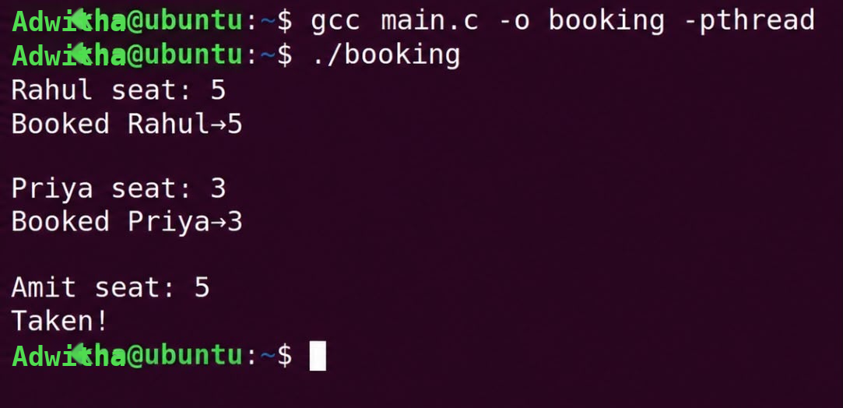

PART B: MUTUAL EXCLUSION WITH SEMAPHORE
Algorithm:
BEGIN
Initialize 11 seats as unoccupied
Initialize semaphore SEM with value 3 and mutex M
Define BOOK(id)
Set seat = id + 1
Wait(SEM)
Display the name of the person
Lock(M)
IF seats[seat] is unoccupied THEN
Mark seats[seat] as occupied and display "Booked -> seat"
ELSE
Display "Taken"
END IF
Unlock(M)
Wait for 1 second
Signal(SEM)
END PROCEDURE
Create four threads for Rahul, Priya, Amit and Sneha
FOR each thread
Execute BOOK(id)
END FOR
FOR each thread
Wait for the thread to complete
END FOR
Destroy SEM
END

Program:
#include <stdio.h>
#include <pthread.h>
#include <semaphore.h>
#include <unistd.h>
int seats[11]={0}; sem_t sem; pthread_mutex_t m=PTHREAD_MUTEX_INITIALIZER;
void *book(void *arg){
int i=*(int*)arg, seat=i+1;
sem_wait(&sem); printf("%s got sem\n",i==0?"Rahul":i==1?"Priya":i==2?"Amit":"Sneha");
pthread_mutex_lock(&m);
if(seats[seat]==0){seats[seat]=1; printf("Booked -> seat %d\n",seat);}
else printf("Taken\n");
pthread_mutex_unlock(&m); sleep(1); sem_post(&sem); return NULL;}
int main(){pthread_t t[4]; int id[]={0,1,2,3}; sem_init(&sem,0,3);
for(int i=0;i<4;i++) pthread_create(&t[i],0,book,&id[i]);
for(int i=0;i<4;i++) pthread_join(t[i],0);sem_destroy(&sem); return 0;}

Program output:

PART C: MUTUAL EXCLUSION WITH SEMAPHORE AND MONITOR
Algorithm:
BEGIN
Initialize 11 seats as unoccupied, semaphore S = 3, mutex M and condition variable C
Define names as Rahul, Priya, Amit and Sneha
PROCEDURE BOOK(id)
Set seat = id + 1
Wait(S)
Lock(M)
WHILE seats[seat] is occupied
Wait(C, M)
END WHILE
Mark seats[seat] as occupied
Display "Booked name -> seat"
Unlock(M)
Wait for 1 second
Lock(M)
Mark seats[seat] as unoccupied
Signal all waiting threads using C
Unlock(M)
Signal(S)
END PROCEDURE
Create four threads and execute BOOK(id) for each person
Wait for all threads to complete
END

Program:
#include <stdio.h>
#include <pthread.h>
#include <semaphore.h>
#include <unistd.h>
int seats[11]={0}; sem_t s; pthread_mutex_t m; pthread_cond_t c;
char *names[]={"Rahul","Priya","Amit","Sneha"};
void *book(void *arg){
int i=*(int*)arg,seat=i+1; sem_wait(&s); printf("%s got sem\n",names[i]);pthread_mutex_lock(&m);
while(seats[seat]) {printf("%s wait\n",names[i]); pthread_cond_wait(&c,&m);};
seats[seat]=1; printf("Booked %s -> %d\n",names[i],seat); pthread_mutex_unlock(&m);
sleep(1); pthread_mutex_lock(&m); seats[seat]=0; pthread_cond_broadcast(&c);
pthread_mutex_unlock(&m); sem_post(&s); return NULL;}
int main(){pthread_t t[4]; int id[]={0,1,2,3}; sem_init(&s,0,3);
pthread_mutex_init(&m,0); pthread_cond_init(&c,0);
for(int i=0;i<4;i++) pthread_create(&t[i],0,book,&id[i]);
for(int i=0;i<4;i++) pthread_join(t[i],0); return 0;}

Program output: 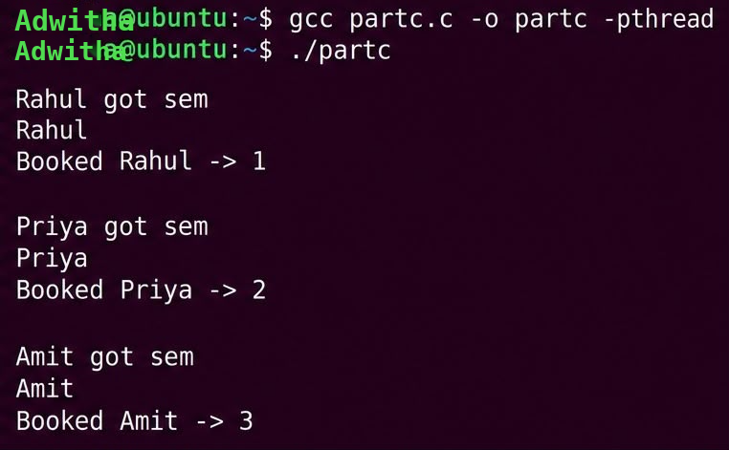
Definitions:
Mutual Exclusion: Mutual exclusion is a synchronization mechanism that ensures only one process or thread can enter a critical section and access a shared resource at a time.

Semaphore: A semaphore is a synchronization variable used to control access to shared resources by multiple processes or threads.
It maintains a counter and mainly uses wait() and signal() operations to manage resource access and synchronization.

Monitor: A monitor is a high-level synchronization mechanism that combines shared data, procedures, and synchronization operations into a single unit.
It allows only one thread to execute within the monitor at a time and uses condition variables to make threads wait or continue when a particular condition is satisfied.

Domain and Use case: Concurrent seat booking system
Result :
Successfully executed Mutual Exclusion using semaphore and monitor

EX:NO:5 Reader-Writer Problem
Aim:To study the Reader –Writer problem
Algorithm:
BEGIN
Initialize product with price = 99.99 and stock = 100
Initialize a read-write lock
PROCEDURE READER(id)
FOR 5 times
Acquire read lock
Display reader ID, product price and stock
Release read lock
Wait for a short time
END FOR
END PROCEDURE
PROCEDURE WRITER
FOR 3 times
Acquire write lock
Decrease product price by 1 and stock by 5
Display updated price and stock
Release write lock
Wait for a short time
END FOR
END PROCEDURE
Create two reader threads and one writer thread
Wait for all three threads to complete
END
Program:
#include <stdio.h>
#include <pthread.h>
#include <unistd.h>
typedef struct { float price; int stock; } Product;
Product p = {99.99, 100};
pthread_rwlock_t lock = PTHREAD_RWLOCK_INITIALIZER;
void* reader(void* arg) {
for(int i=0;i<5;i++){
pthread_rwlock_rdlock(&lock);
printf("R%d: price=%.2f stock=%d\n",*(int*)arg,p.price,p.stock);
pthread_rwlock_unlock(&lock);
usleep(100000); }
return NULL;}
void* writer(void* arg) {
for(int i=0;i<3;i++){
pthread_rwlock_wrlock(&lock);
p.price -= 1.0; p.stock -= 5;
printf("W: updated price=%.2f stock=%d\n",p.price,p.stock);
pthread_rwlock_unlock(&lock);
usleep(200000); }./
return NULL;
}
int main() {
pthread_t r1,r2,w;
int id1=1,id2=2;
pthread_create(&r1,NULL,reader,&id1);
pthread_create(&r2,NULL,reader,&id2);
pthread_create(&w,NULL,writer,NULL);
pthread_join(r1,NULL); pthread_join(r2,NULL); pthread_join(w,NULL);
return 0;
}
Definitions:
Reader-Writer Problem: The Reader-Writer problem is a synchronization problem where multiple processes or threads share a common data resource.
Multiple readers can read the resource simultaneously, but a writer must have exclusive access while modifying the resource.
Synchronization is required to prevent data inconsistency and conflicts between readers and writers.
Domain and Use Case: Concurrent product inventory Management

Program output: 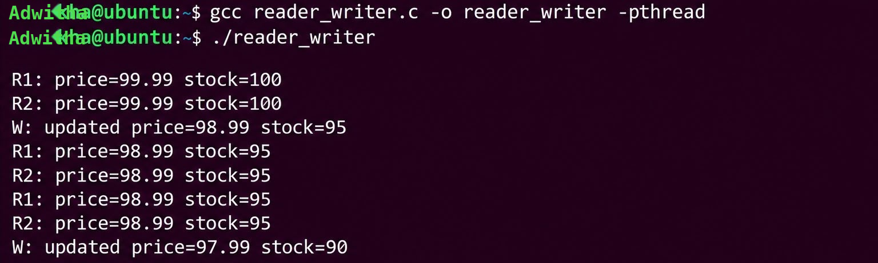

Result: Thus Successfully provided a solution to Reader – Writer using mutex and semaphore.

EX :NO :6 Dining Philosopher’s Problem
Aim:To implement and study Dining Philosopher’s Problem
Algorithm:
BEGIN
Read the number of cars N
Initialize N road mutexes
PROCEDURE CAR(i)
Lock road[i]
Display "Car i reserved road[i]"
Lock road[(i + 1) MOD N]
Display "Car i moving through road (i + 1) MOD N"
Unlock road[(i + 1) MOD N]
Unlock road[i]
END PROCEDURE
Create N car threads
FOR each car from 0 to N-1
Assign car ID
Create a thread to execute CAR(car ID)
END FOR
FOR each car thread
Wait for the thread to complete
END FOR
END

Program:
#include <stdio.h>
#include <pthread.h>
int N; pthread_mutex_t road[20];
void *car(void *arg){int i=*(int*)arg;
pthread_mutex_lock(&road[i]);
printf("Car %d reserved road[%d]\n",i,i);
pthread_mutex_lock(&road[(i+1)%N]);
printf("Car %d moving through road %d\n",i,(i+1)%N);
pthread_mutex_unlock(&road[(i+1)%N]);
pthread_mutex_unlock(&road[i]);return NULL;}

int main(){
printf("Enter number of cars: "); scanf("%d",&N);
pthread_t c[N]; int id[N];
for(int i=0;i<N;i++) pthread_mutex_init(&road[i],NULL),id[i]=i,pthread_create(&c[i],NULL,car,&id[i]);
for(int i=0;i<N;i++) pthread_join(c[i],NULL);return 0;
}

Definition:
Dining Philosophers Problem: The Dining Philosophers Problem is a classic synchronization problem in which multiple philosophers sit around a table and share limited resources called forks.
Each philosopher needs two forks to eat, so improper resource allocation can cause deadlock, starvation, or indefinite waiting.
Synchronization techniques such as mutexes and semaphores are used to coordinate access to the shared forks.
Domain and Use Case: Concurrent Road Resource Sharing

Program output: 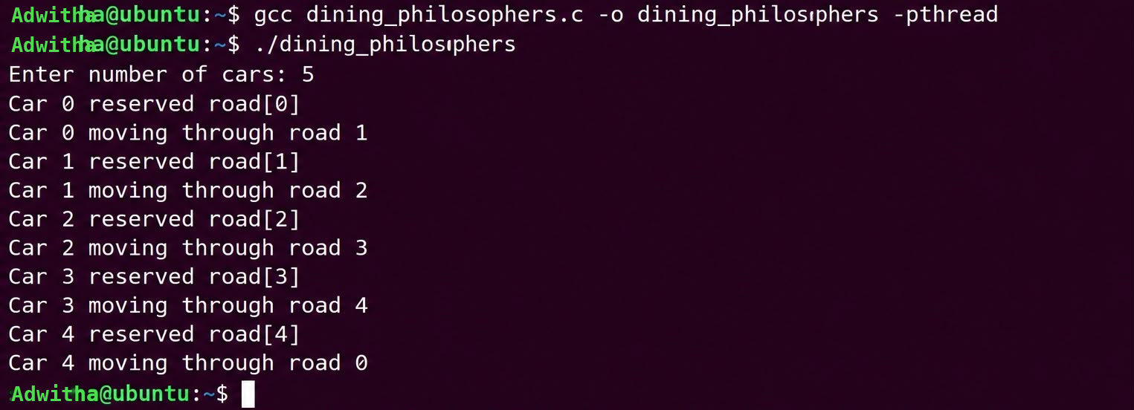

Result: Thus Successfully implemented the concepts of Dining Philosophers Problem.

EX:NO 7 Bankers Algorithm for Deadlock avoidance
Aim :
To implement and study Bankers Algorithm for Deadlock Avoidance Problem
PART A: DEADLOCK
Algorithm
BEGIN
Initialize two track mutexes
Read user choice to start the deadlock demonstration
PROCEDURE TRAIN_A
Lock Track-0
Display "Train A locked Track-0, waiting for Track-1"
Wait for 1 second
Lock Track-1
Train A enters the track
END PROCEDURE
PROCEDURE TRAIN_B
Lock Track-1
Display "Train B locked Track-1, waiting for Track-0"
Wait for 1 second
Lock Track-0
Train B enters the track
END PROCEDURE
Create two threads for Train A and Train B
Execute TRAIN_A and TRAIN_B concurrently
Wait for both threads to complete
END

Program
#include <stdio.h>
#include <pthread.h>
#include <unistd.h>
pthread_mutex_t track[2];
void *trainA(void *arg) {
printf("Train A locked Track-0, waiting for Track-1...\n");
pthread_mutex_lock(&track[0]); sleep(1);
pthread_mutex_lock(&track[1]);return NULL;
}void *trainB(void *arg) {
printf("Train B locked Track-1, waiting for Track-0...\n");
pthread_mutex_lock(&track[1]);sleep(1);
pthread_mutex_lock(&track[0]); return NULL;
}int main() {
int choice;
printf("Enter 1 to start deadlock demo: ");
scanf("%d", &choice);
pthread_t t1, t2;
pthread_mutex_init(&track[0], NULL);
pthread_mutex_init(&track[1], NULL);
pthread_create(&t1, NULL, trainA, NULL);
pthread_create(&t2, NULL, trainB, NULL);
pthread_join(t1, NULL);pthread_join(t2, NULL); return 0;}

Program Output: 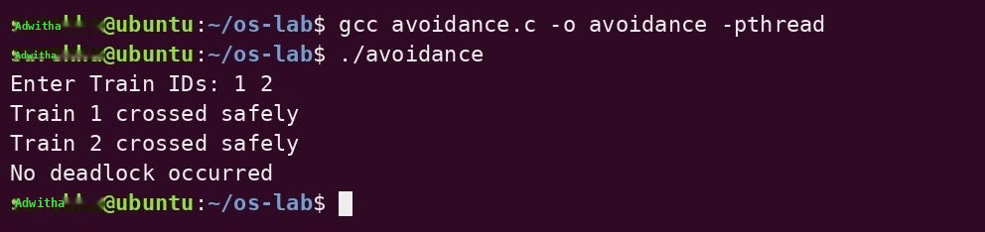
PART B: DEADLOCK AVOIDANCE
Algorithm:
BEGIN
DECLARE mutex T0, T1
DECLARE train IDs x, y
INPUT x, y
FUNCTION TRAIN(id)
LOCK T0
SLEEP(1)
LOCK T1
PRINT "Train id crossed safely"
UNLOCK T1
UNLOCK T0
END FUNCTION
CREATE THREAD a FOR TRAIN(x)
CREATE THREAD b FOR TRAIN(y)
JOIN a
JOIN b
PRINT "No deadlock occurred"
END

Program:
#include <stdio.h>
#include <pthread.h>
#include <unistd.h>
pthread_mutex_t t0, t1;
void *train(void *id) {
int tid = *(int*)id;
pthread_mutex_lock(&t0);
sleep(1);
pthread_mutex_lock(&t1);
printf("Train %d crossed safely\n", tid);
pthread_mutex_unlock(&t1);
pthread_mutex_unlock(&t0);
return NULL;
}
int main() {int x, y;
printf("Enter Train IDs: ");
scanf("%d %d", &x, &y);
pthread_t a, b;
pthread_mutex_init(&t0, NULL);
pthread_mutex_init(&t1, NULL);
pthread_create(&a, NULL, train, &x);
pthread_create(&b, NULL, train, &y);
pthread_join(a, NULL); pthread_join(b, NULL);
printf("No deadlock occurred\n");
return 0;
}
Program Output: 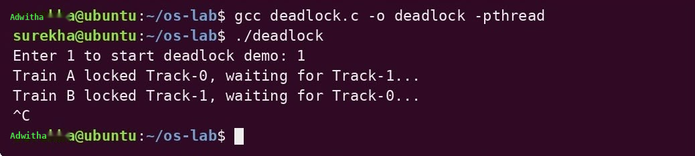

PART C: DEADLOCK AVOIDANCE USING BANKERS ALGORITHM
Algorithm:
BEGIN
DECLARE number of processes n and number of resources r
INPUT n and r
DECLARE Available[r], Allocation[n][r], Need[n][r], Finished[n]
INPUT Available resources
INPUT Allocation matrix
INPUT Need matrix
FOR each process i
Set Finished[i] = FALSE
END FOR
FOR each process i
IF Finished[i] = FALSE THEN
Check whether Need[i][j] <= Available[j] for every resource j
IF all resources are available THEN
FOR each resource j
Available[j] = Available[j] + Allocation[i][j]
END FOR
Set Finished[i] = TRUE
END IF
END IF
END FOR
Set State = SAFE
FOR each process i
IF Finished[i] = FALSE THEN
Set State = DEADLOCK
END IF
END FOR
Display "Railway Reservation State: " + State
END

Program:
#include <stdio.h>
int main(){
int n,r,i,j,ok=1;
printf("Enter matrix dimensions (processes resources): "); scanf("%d%d",&n,&r);
int a[r],al[n][r],nd[n][r],f[n];
printf("Enter available resources: "); for(i=0;i<r;i++)scanf("%d",&a[i]);
printf("Enter Allocation matrix (%d x %d):\n",n,r);
for(i=0;i<n;i++)for(j=0;j<r;j++)scanf("%d",&al[i][j]);
printf("Enter Need matrix (%d x %d):\n",n,r);
for(i=0;i<n;i++){f[i]=0;for(j=0;j<r;j++)scanf("%d",&nd[i][j]);}
for(i=0;i<n;i++)if(!f[i]){for(j=0;j<r;j++)if(nd[i][j]>a[j])break;
if(j==r){for(j=0;j<r;j++)a[j]+=al[i][j];f[i]=1;}}
for(i=0;i<n;i++)if(!f[i])ok=0;
printf("Railway Reservation State: %s",ok?"SAFE":"DEADLOCK");
}
Program output: 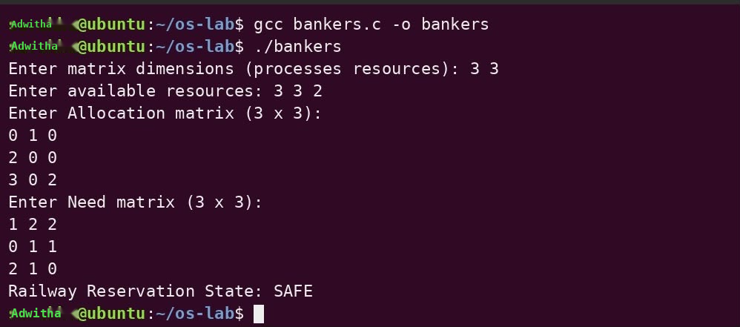

Definition:
Deadlock:
A deadlock is a situation in which two or more processes are permanently blocked because each process is waiting for a resource held by another process. As a result, none of the processes can continue execution.
Causes of Deadlock:
Deadlock occurs when the following four conditions are present simultaneously:
Mutual Exclusion: A resource can be used by only one process at a time. Other processes must wait for it.
Hold and Wait: A process holds one or more resources while waiting for additional resources that are currently unavailable.
No Preemption: A resource allocated to a process cannot be forcibly taken away. It can only be released voluntarily by the process.
Circular Wait: A group of processes forms a circular chain where each process waits for a resource held by another process.
Deadlock Handling:
Deadlock handling refers to techniques used by an operating system to prevent, avoid, detect, or recover from deadlocks.
Deadlock Prevention: Deadlock prevention ensures that at least one of the four necessary conditions for deadlock does not occur.
• Prevent Hold and Wait by making processes request resources together.
• Prevent Circular Wait by assigning an order to resources.
• Prevent No Preemption by allowing resources to be taken back when needed.
• Reduce Mutual Exclusion by making resources shareable whenever possible.
Deadlock Avoidance: Deadlock avoidance allocates resources carefully so that the system never enters an unsafe state. Before granting a request, the OS checks whether the allocation keeps the system in a safe state. Banker's Algorithm is used for this purpose.
Deadlock Detection: Deadlock detection allows deadlocks to occur and periodically checks resource allocation and waiting processes to identify whether a deadlock has occurred.
Deadlock Recovery: Deadlock recovery removes a deadlock after it has been detected. The main methods are:
• Process Termination: Terminate one or more deadlocked processes.
• Resource Preemption: Take resources from one process and allocate them to another.
• Process Rollback: Restore a process to a previously saved safe state and restart it.
Domain and Use Case: Train track Deadlock Demonstration

Result : Successfully implemented the concepts of Banker’s Algorithm.

EX:NO:8 FCFS and SJF Scheduling
Aim :
To study the concepts of FCFS and SJF Scheduling
PART A :FCFS Scheduling
Algorithm:
BEGIN
Set applications = Instagram, Whatsapp, Youtube
Set burst times = 2, 4, 6
Set number of applications n = 3
Set waiting time of first application = 0
FOR i = 1 to n-1
waiting[i] = waiting[i-1] + burst[i-1]
END FOR
Display "FCFS CPU Scheduling"
Display application, burst time, waiting time and turnaround time
FOR i = 0 to n-1
turnaround[i] = waiting[i] + burst[i]
Display application name, burst time, waiting time and turnaround time
END FOR
END

Program:
#include <stdio.h>
int main()
{ char *app[] = {"Instagram", "Whatsapp", "Youtube"};
int burst[] = {2, 4, 6};
int waiting[3], turnaround[3];
int n = 3;
waiting[0] = 0;
for (int i = 1; i < n; i++) {
waiting[i] = waiting[i - 1] + burst[i - 1];}
printf("FCFS CPU scheduling\n");
printf("App\t\tBurst\tWaiting\tTurnaround\n");
for (int i = 0; i < n; i++)
{
turnaround[i] = waiting[i] + burst[i];
printf("%-10s\t%d\t%d\t%d\n",
app[i], burst[i], waiting[i], turnaround[i]);
}
return 0;
}
Program output: 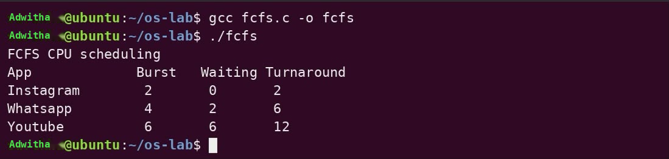

PART B :SJF Scheduling
Algorithm:
BEGIN
Set applications = Instagram, Whatsapp, Youtube
Set burst times = 5, 2, 4
FOR i = 0 to 2
FOR j = i + 1 to 2
IF burst[i] > burst[j] THEN
Swap burst[i] and burst[j]
Swap application[i] and application[j]
END IF
END FOR
END FOR
Display "SJF CPU Scheduling"
Set waiting time = 0
FOR i = 0 to 2
Display application name, burst time and waiting time
waiting time = waiting time + burst[i]
END FOR
END

Program:
#include <stdio.h>
int main()
{char *app[] = {"Instagram", "Whatsapp", "Youtube"};
int bt[] = {5, 2, 4}, i, j, t;
for (i = 0; i < 3; i++){for (j = i + 1; j < 3; j++){
if (bt[i] > bt[j]){t = bt[i];bt[i] = bt[j];bt[j] = t;
char *p = app[i];
app[i] = app[j];
app[j] = p;
}}}
printf("SJF CPU scheduling\n");
int wt = 0;
for (i = 0; i < 3; i++)
{printf("%s Burst = %d Waiting = %d\n",
app[i], bt[i], wt);
wt = wt + bt[i];}
return 0;
}

Program Output: 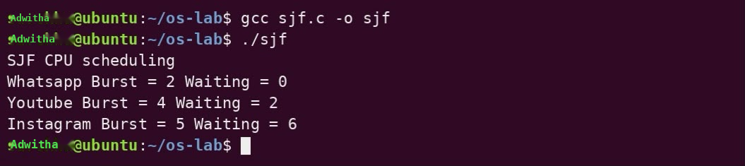

Definition:
FCFS (First Come First Serve): FCFS is a non-preemptive CPU scheduling algorithm where processes are executed in the order they arrive in the ready queue. The first process to arrive gets the CPU first and runs until completion. It is simple to implement but may cause high waiting time and the convoy effect.
Real-life example: People are served at a bank counter in the same order as they join the queue.
SJF (Shortest Job First): SJF is a CPU scheduling algorithm where the process with the shortest CPU burst time is executed first. In non-preemptive SJF, the selected process runs until completion. It can reduce average waiting time but may cause starvation of longer processes.
Real-life example: A printer handles small print jobs before longer print jobs to finish more tasks quickly.
Domain and Usecase: Social Media CPU scheduling

Result : Implemented the concepts of FCFS and SJF Scheduling in C successfully.

EX: NO: 9 Priority and Round Robin Scheduling
Aim :To study the concepts of Priority and Round Robin Scheduling
PART A:Priority Scheduling
Algorithm:

BEGIN
DEFINE instruments = ["GPS", "HeartRate", "Oxygen", "ECG"]
DEFINE burst_time = [5, 3, 4, 6]
DEFINE priority = [3, 1, 2, 1]
DEFINE order = [0, 1, 2, 3]
DEFINE current_time = 0
DEFINE n = 4
// Sort 'order' by priority using bubble sort (ascending priority = higher priority first)
FOR i = 0 TO n-2 DO
FOR j = 0 TO (n-2-i) DO
IF priority[order[j]] > priority[order[j+1]] THEN
SWAP order[j] AND order[j+1]
END IF
END FOR
END FOR
PRINT "Instrument | Priority | Start | Finish"
FOR i = 0 TO n-1 DO
idx = order[i]
PRINT instruments[idx], priority[idx], current_time, current_time + burst_time[idx]
current_time = current_time + burst_time[idx]
END FOR
PRINT "All instruments monitored successfully."
END

Program:
#include <stdio.h>
int main() {
char *inst[] = {"GPS", "HeartRate", "Oxygen", "ECG"};
int burst[] = {5, 3, 4, 6}, pri[] = {3, 1, 2, 1};
int order[] = {0,1,2,3}, time = 0;
for(int i=0; i<3; i++)
for(int j=0; j<3-i; j++)
if(pri[order[j]] > pri[order[j+1]]) {
int t = order[j]; order[j] = order[j+1]; order[j+1] = t;
}
printf("Instrument | Priority | Start | Finish\n");
for(int i=0; i<4; i++) {
int idx = order[i];
printf("%-10s | %8d | %5d | %6d\n", inst[idx], pri[idx], time, time+burst[idx]);
time += burst[idx];
}
printf("\nAll instruments monitored successfully.\n");
return 0;
}
Program Output: 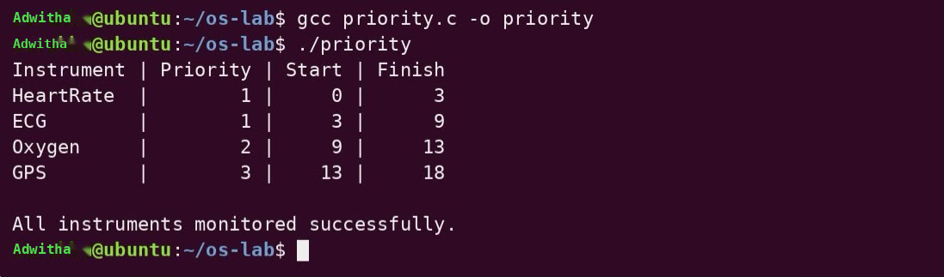

PART B:Round Robin Scheduling
Algorithm:
BEGIN
DEFINE instruments = ["GPS", "HeartRate", "Oxygen", "ECG"]
DEFINE burst_time = [5, 3, 4, 6]
DEFINE remaining_time = COPY OF burst_time
DEFINE time_quantum = 2
DEFINE current_time = 0
DEFINE completed_count = 0
DEFINE n = 4
PRINT "Time | Instrument | Remaining"
WHILE completed_count < n DO
FOR i = 0 TO n-1 DO
IF remaining_time[i] > 0 THEN
IF remaining_time[i] > time_quantum THEN
run_time = time_quantum
ELSE
run_time = remaining_time[i]
END IF
current_time = current_time + run_time
remaining_time[i] = remaining_time[i] - run_time
PRINT current_time, instruments[i], remaining_time[i]
IF remaining_time[i] == 0 THEN
completed_count = completed_count + 1
END IF
END IF
END FOR
END WHILE
PRINT "All instruments monitored successfully."
END
Program:
#include <stdio.h>
int main() {
char *inst[] = {"GPS", "HeartRate", "Oxygen", "ECG"};
int burst[] = {5, 3, 4, 6}, rem[4], tq = 2, time = 0, done = 0;
for(int i = 0; i < 4; i++) rem[i] = burst[i];
printf("Time | Instrument | Remaining\n");
while(done < 4) {
for(int i = 0; i < 4; i++) {
if(rem[i] > 0) {
int run = (rem[i] > tq) ? tq : rem[i];
time += run; rem[i] -= run;
printf("%4d | %-10s | %d\n", time, inst[i], rem[i]);
if(rem[i] == 0) done++;
}}}
printf("\nAll instruments monitored successfully.\n");
return 0;}
Program Output: 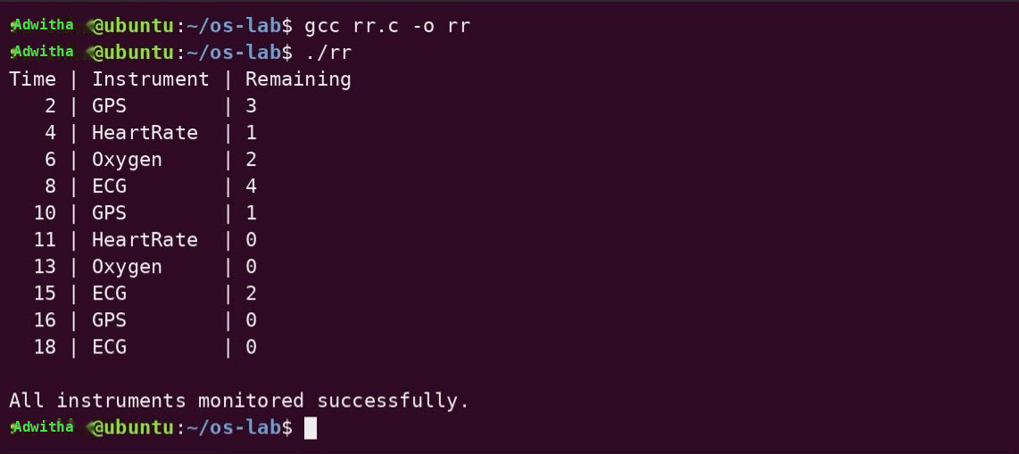

Definitions:
Priority Scheduling
Priority Scheduling is a CPU scheduling algorithm in which every process is assigned a priority. The CPU is allocated to the process having the highest priority. Usually, a smaller priority number indicates a higher priority.
Round Robin Scheduling:
Round Robin Scheduling is a preemptive CPU scheduling algorithm in which each process is given a fixed amount of CPU time called a time quantum or time slice.
Processes in the ready queue are executed one after another in a circular manner. If a process does not finish within its time quantum, it is moved to the end of the ready queue and the next process gets the CPU. This continues until all processes are completed
Domain and usecase: Ambulance instrument Monitoring system

Result : Implemented the concepts of Priority Scheduling and Round Robin Scheduling in C successfully

EX: NO:10 FIFO Page Replacement Algorithm
Aim:To implement FIFO page replacement algorithm
PART A:FIFO
Algirthm:
BFS(start, goal)
Create an empty queue
Mark start as visited
Insert start into the queue
While queue is not empty:
Remove the front node from queue → u
If u = goal:
Stop
For every neighbour v of u:
If v is not visited:
Mark v as visited
Store u as predecessor of v
Insert v into queue
Start from goal
Follow predecessors until start is reached
Reverse the path
Print the path
Program:
#include <string.h>
#define N 6
char *nodes[] = {"A","B","C","D","E","F"};
int graph[N][N] = {{0,1,1,0,0,0},{1,0,0,1,1,0},{1,0,0,0,0,1},
{0,1,0,0,0,0},{0,1,0,0,0,1},{0,0,1,0,1,0}};
void bfs(int start, int goal) {
int q[N], front=0, rear=0, vis[N]={0}, prev[N];
memset(prev, -1, sizeof(prev));
q[rear++]=start; vis[start]=1;
while(front<rear){
int u=q[front++];
if(u==goal) break;
for(int v=0;v<N;v++) if(graph[u][v]&&!vis[v]){
vis[v]=1; prev[v]=u; q[rear++]=v;
}}
int path[N], len=0;
for(int u=goal;u!=-1;u=prev[u]) path[len++]=u;
for(int i=len-1;i>=0;i--) printf("%s%s",nodes[path[i]],i?" -> ":"");
printf("\n");
}

int main(){
printf("FIFO Page Replacement Algorithm \nGoogle Maps – Route Navigation \n");
bfs(0,5); }
Program output: 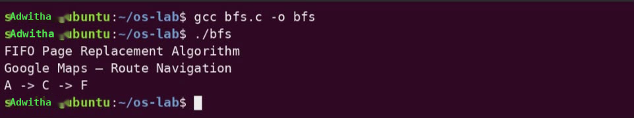

PART B : Page replacement algorithm
Algorithm:
Initialize all frames as empty (-1)
Set page_faults = 0
For each page in the reference string:
Check if page is already in a frame
If yes → Page Hit
If page is not found:
If an empty frame exists:
Insert the page into it
Else:
For each page currently in the frames:
Look ahead in the reference string
Find when that page will be used next

Select the page whose next use is farthest
Replace that page with the current page
Increment page_faults
Display the current page and frames
Print total page faults
Program:
#include <stdio.h>
int main() {
int pages[]={7,0,1,2,0,3,0,4,2,3,0,3,2}, n=13, f=3;
int frame[3]={-1,-1,-1}, faults=0, i, j, k, pos, farthest;
for(i=0; i<n; i++) {
int found=0;
for(j=0; j<f; j++) if(frame[j]==pages[i]) {found=1; break;}
if(!found) {
int empty=-1;
for(j=0; j<f; j++) if(frame[j]==-1) {empty=j; break;}
if(empty!=-1) frame[empty]=pages[i];
else {
farthest=-1; pos=0;
for(j=0; j<f; j++) {
int next=n;
for(k=i+1; k<n; k++) if(frame[j]==pages[k]) {next=k; break;}
if(next>farthest) {farthest=next; pos=j;}
}
frame[pos]=pages[i];
}
faults++;
}
printf("%d → ", pages[i]);
for(j=0; j<f; j++) printf("%2d ", frame[j]);
printf("\n");
}
printf("Total Page Faults = %d\n", faults);
}
Program output: 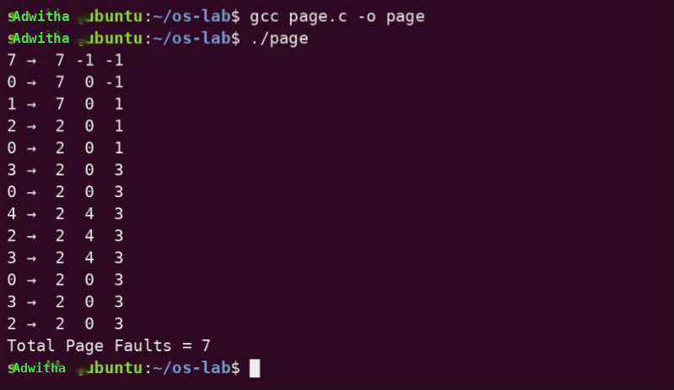

PART C: FIFO Page Replacement Algorithm
Algorithm:
BEGIN
Define 6 locations as A, B, C, D, E and F
Define the connections between the locations using an adjacency matrix
PROCEDURE BFS(start, goal)
Initialize an empty queue
Mark all locations as unvisited
Set previous location of each node to -1
Add start location to the queue and mark it visited
WHILE queue is not empty
Remove the front location from the queue
IF current location = goal THEN
BREAK
END IF
FOR each connected location
IF location is not visited THEN
Mark it visited
Store current location as its previous location
Add it to the queue
END IF
END FOR
END WHILE
Trace the path from goal back to start using previous locations
Display the route from start to goal
END PROCEDURE
Display "Google Maps – Route Navigation"
Call BFS(A, F)
END
Porgram:
#include <stdio.h>
int main() {
int pages[]={7,0,1,2,0,3,0,4,2,3,0,3,2}, n=13, f=3;
int frame[3]={-1,-1,-1}, front=0, faults=0, i,j,hit;
printf("Map Tile Requests → Frames (FIFO Cache)\n");
for(i=0;i<n;i++){
hit=0;
for(j=0;j<f;j++) if(frame[j]==pages[i]){hit=1;break;}
if(!hit){frame[front]=pages[i]; front=(front+1)%f; faults++;}
printf("Tile %d → ",pages[i]);
for(j=0;j<f;j++) printf("%2d ",frame[j]);
printf("\n");
}
printf("Total Cache Misses (Page Faults) = %d\n",faults);
}

Program Output: 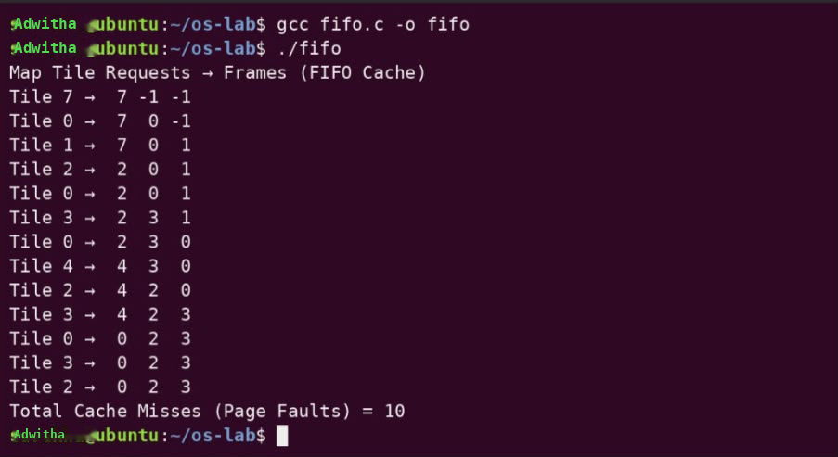

Definitions:
FIFO (First-In, First-Out) Page Replacement
FIFO Page Replacement is a page replacement algorithm used in virtual memory management. When a page fault occurs and all the available frames are occupied, the page that has been in memory for the longest time is removed and replaced with the newly required page.
FIFO maintains the pages in the order in which they entered memory. The oldest page is replaced first, regardless of how frequently or recently that page is being used.

Domain and usecase: Google maps

Result :
Successfully implemented page replacement using FIFO algorithm

EX NO 11: LRU AND LFU PAGE REPLACEMENT ALGORITHMS
Aim: To implement page replacement using LRU and LFU
PART A LRU page replacement algorithm
Algorithm
CONSTANT N ← 5
ARRAY cache[0 … N-1]
front ← 0
rear ← -1
count ← 0
PROCEDURE insert(x)
IF count = N THEN
PRINT "Evict", cache[front]
front ← (front + 1) MOD N
count ← count - 1
END IF
rear ← (rear + 1) MOD N
cache[rear] ← x
count ← count + 1
END PROCEDURE
PROCEDURE display()
j ← front
FOR i ← 0 TO count - 1 DO
PRINT cache[j]
j ← (j + 1) MOD N
END FOR
PRINT newline
END PROCEDURE
PROCEDURE main()
PRINT "Enter product IDs (0 to stop):"
WHILE TRUE DO
READ x
IF x = 0 THEN
BREAK
END IF
insert(x)
END WHILE
display()
END PROCEDURE
Program
#include <stdio.h>
#define N 5
int cache[N], front=0, rear=-1, count=0;
void insert(int x){if(count==N){printf("Evict %d\n",cache[front]);front=(front+1)%N;count--;}
rear=(rear+1)%N;cache[rear]=x;count++;}
void display(){for(int i=0,j=front;i<count;i++,j=(j+1)%N)printf("%d ",cache[j]);printf("\n");}
int main(){int x;printf("Enter product IDs (0 to stop):\n");
while(scanf("%d",&x)==1&&x!=0)insert(x);display();return 0;}
Program output: 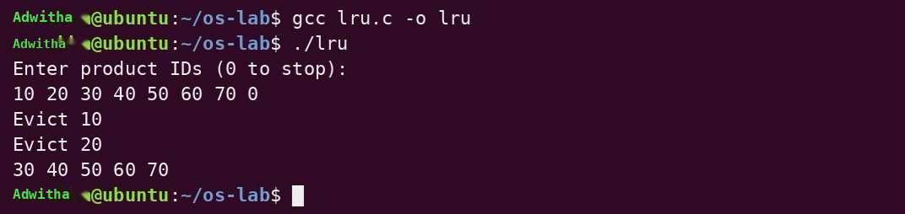

PART B: LFU page replacement algorithm
Algorithm
CONSTANT N ← 5
ARRAY id[0 … N-1]
ARRAY freq[0 … N-1]
INTEGER size ← 0
PROCEDURE Insert(x)
// Check if product already present
FOR i ← 0 TO size-1 DO
IF id[i] = x THEN
freq[i] ← freq[i] + 1
RETURN
END IF
END FOR
IF size = N THEN // Cache is full → evict LFU
m ← 0
FOR i ← 1 TO N-1 DO
IF freq[i] < freq[m] THEN
m ← i
END IF
END FOR
PRINT "Evict", id[m], "(freq", freq[m], ")"
id[m] ← x
freq[m] ← 1
ELSE // Space available
id[size] ← x
freq[size] ← 1
size ← size + 1
END IF
END PROCEDURE
PROCEDURE Display
FOR i ← 0 TO size-1 DO
PRINT id[i], "(", freq[i], ") "
END FOR
PRINT newline
END PROCEDURE
PROCEDURE Main
PRINT "Enter product IDs (0 to stop):"
WHILE TRUE DO
READ x
IF x = 0 THEN BREAK
Insert(x)
END WHILE
Display()
END PROCEDURE
Program
#include <stdio.h>
#define N 5
int id[N], freq[N], size=0;
void insert(int x){
for(int i=0;i<size;i++)if(id[i]==x){freq[i]++;return;}
if(size==N){int m=0;for(int i=1;i<N;i++)if(freq[i]<freq[m])m=i;
printf("Evict %d (freq %d)\n",id[m],freq[m]);id[m]=x;freq[m]=1;}
else{id[size]=x;freq[size++]=1;}}
void display(){for(int i=0;i<size;i++)printf("%d(%d) ",id[i],freq[i]);printf("\n");}
int main(){int x;printf("Enter product IDs (0 to stop):\n");
while(scanf("%d",&x)==1&&x)insert(x);display();return 0;}
Program output:

Definitions:
LRU Page Replacement Algorithm
LRU (Least Recently Used) is a page replacement algorithm in which, when a page fault occurs and all memory frames are full, the page that has not been used for the longest period of time is replaced.
LRU keeps track of the recent usage of pages. When replacement is required, the page that was used least recently is removed, and the newly required page is loaded into memory.
LFU Page Replacement Algorithm
LFU (Least Frequently Used) is a page replacement algorithm in which, when a page fault occurs and all memory frames are full, the page that has been used the least number of times is replaced.
LFU maintains a frequency count for each page. Every time a page is accessed, its count is increased. When replacement is required, the page with the lowest frequency count is selected for removal.

Domain and usecase: Supermarket Billing Syste

Result : Successfully implemented page replacement using LRU and LFU algorithms

EX: NO: 12 :Best fit and Worst fit memory management policies
Aim:To implement and study Best fit and Worst fit memory management policies
in C.
PART A: Best fit memory management policies
Algorithm:
START
READ number of memory blocks n
READ sizes of all memory blocks
READ number of processes m
READ sizes of all processes
FOR each process i
best = -1
FOR each block j
IF block[j] >= process[i] AND
(best == -1 OR block[j] < block[best])
best = j
END IF
END FOR
IF best != -1
ALLOCATE process i to block best
REDUCE block[best] by process[i]
ELSE
MARK process i as not allocated
END IF
END FOR

DISPLAY process number, size and allocated block
STOP
Program:
#include <stdio.h>
int main() {
int n, m, i, j, best;
printf("Enter number of memory blocks: ");
scanf("%d", &n);
int block[n];
printf("Enter sizes of %d blocks:\n", n);
for(i=0; i<n; i++) scanf("%d", &block[i]);
printf("Enter number of processes: ");
scanf("%d", &m);
int process[m], alloc[m];
printf("Enter sizes of %d processes:\n", m);
for(i=0; i<m; i++) scanf("%d", &process[i]);
for(i=0; i<m; i++) {
best = -1;
for(j=0; j<n; j++)
if(block[j] >= process[i] && (best==-1 || block[j] < block[best]))
best = j;
if(best != -1) {
alloc[i] = best;
block[best] -= process[i];
} else
alloc[i] = -1;
}
printf("\nProcess\tSize\tBlock\n");
for(i=0; i<m; i++)
printf("%d\t%d\t%d\n", i+1, process[i], alloc[i]!=-1 ? alloc[i]+1 : -1);
return 0;
}
Program output : 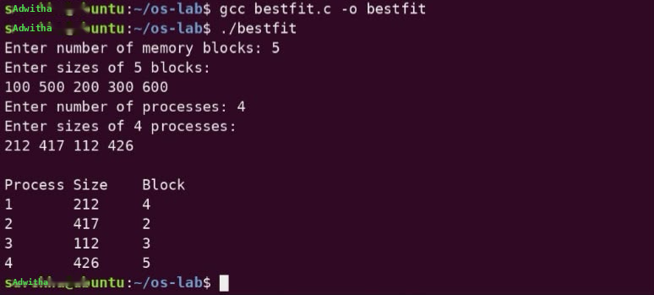

PART B:Worst fit memory management policies
Algorithm:
START
READ number of memory blocks n
READ sizes of all memory blocks
READ number of processes m
READ sizes of all processes
FOR each process i
worst = -1
FOR each block j
IF block[j] >= process[i] AND
(worst == -1 OR block[j] > block[worst])
worst = j
END IF
END FOR
IF worst != -1
ALLOCATE process i to block worst
REDUCE block[worst] by process[i]
ELSE
MARK process i as not allocated
END IF
END FOR
DISPLAY process number, size and allocated block
STOP
Program:
#include <stdio.h>
int main() {
int n, m, i, j, worst;
printf("Enter number of memory blocks: ");
scanf("%d", &n);
int block[n];
printf("Enter sizes of %d blocks:\n", n);
for(i=0; i<n; i++) scanf("%d", &block[i]);

printf("Enter number of processes: ");
scanf("%d", &m);
int process[m], alloc[m];
printf("Enter sizes of %d processes:\n", m);
for(i=0; i<m; i++) scanf("%d", &process[i]);
for(i=0; i<m; i++) {
worst = -1;
for(j=0; j<n; j++)
if(block[j] >= process[i] && (worst==-1 || block[j] > block[worst]))
worst = j;
if(worst != -1) {
alloc[i] = worst;
block[worst] -= process[i];
} else
alloc[i] = -1;
}
printf("\nProcess\tSize\tBlock\n");
for(i=0; i<m; i++)
printf("%d\t%d\t%d\n", i+1, process[i], alloc[i]!=-1 ? alloc[i]+1 : -1);
return 0;
}
Program output :

PART C:Best and Worst fit memory management policies
Algorithm:
START
READ number of blocks n and their sizes
COPY block sizes into a temporary array
READ number of processes m and their sizes
FOR each process i
best = -1, worst = -1
FOR each block j
IF block[j] >= process[i] AND
(best == -1 OR block[j] < block[best])
best = j
END IF
IF temp[j] >= process[i] AND
(worst == -1 OR temp[j] > temp[worst])
worst = j
END IF
END FOR
IF best != -1
ALLOCATE process to best block
REDUCE its size
ELSE
MARK as not allocated
END IF
IF worst != -1
ALLOCATE process to worst block
REDUCE its size
ELSE
MARK as not allocated
END IF
END FOR
DISPLAY Best Fit allocations
DISPLAY Worst Fit allocations
STOP
Program:
#include <stdio.h>
int main() {
int n,m,i,j,b,w,blk[20],tmp[20],p[20],ba[20],wa[20];
printf("Enter no. of blocks: "); scanf("%d",&n);
printf("Enter block sizes: ");
for(i=0;i<n;i++){scanf("%d",&blk[i]);tmp[i]=blk[i];}
printf("Enter no. of processes: "); scanf("%d",&m);
printf("Enter process sizes: ");
for(i=0;i<m;i++)scanf("%d",&p[i]);
for(i=0;i<m;i++){b=w=-1;
for(j=0;j<n;j++){if(blk[j]>=p[i]&&(b==-1||blk[j]<blk[b]))b=j;
if(tmp[j]>=p[i]&&(w==-1||tmp[j]>tmp[w]))w=j;}
if(b!=-1){ba[i]=b;blk[b]-=p[i];}else ba[i]=-1;
if(w!=-1){wa[i]=w;tmp[w]-=p[i];}else wa[i]=-1;}
printf("\nBest Fit:\n");
for(i=0;i<m;i++)printf("P%d -> %d\n",i+1,ba[i]!=-1?ba[i]+1:-1);
printf("\nWorst Fit:\n");
for(i=0;i<m;i++)printf("P%d -> %d\n",i+1,wa[i]!=-1?wa[i]+1:-1);
}
Program output : 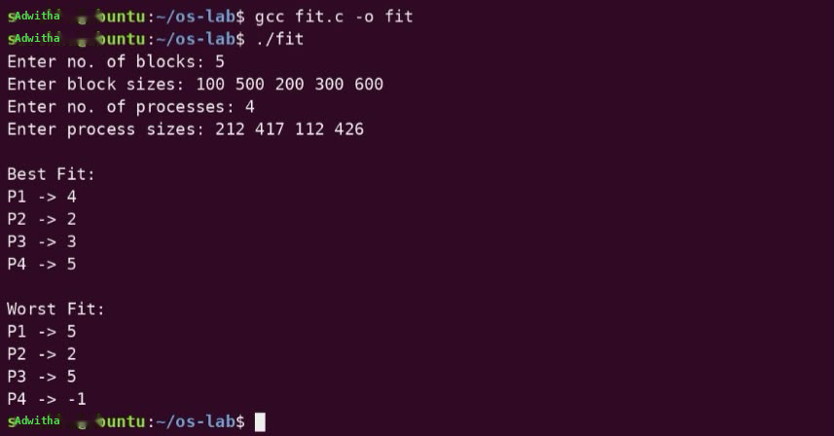

Definitions :
Best Fit Memory Management
Best Fit is a memory allocation technique in which a process is allocated to the smallest available memory block that is large enough to accommodate it. It aims to minimize the unused space in the selected memory block. However, it can result in many small fragments of unused memory, leading to external fragmentation.
Worst Fit Memory Management
Worst Fit is a memory allocation technique in which a process is allocated to the largest available memory block that can accommodate it.The idea is to leave a larger remaining space after allocation, which may be useful for other processes. However, it can also lead to inefficient memory utilization.

Domain and use case : Cloud Platform VM Memory Management

Result : Successfully implemented and studied Best fit and Worst fit memory management policies in C.

EX NO 13 : Disk scheduling Algorithms
Aim :To implement and study disk scheduling algorithms
Algorithm :
CONSTANT M ← 20
CONSTANT DISK_SIZE ← 200 // tracks 0 … 199
PROCEDURE Sort(A[], n)
FOR i ← 0 TO n-1 DO
FOR j ← i+1 TO n-1 DO
IF A[i] > A[j] THEN
Swap A[i] and A[j]
END IF
END FOR
END FOR
END PROCEDURE
BEGIN
Input n
Input request[0 … n-1]
Input head, direction
// Make a working copy that includes the head
FOR i ← 0 TO n-1 DO
temp[i] ← request[i]
END FOR
temp[n] ← head
Sort(temp, n+1)

// ---------- FCFS ----------
PRINT "FCFS: " , head
total ← 0
current ← head
FOR i ← 0 TO n-1 DO
total ← total + |current − request[i]|
current ← request[i]
PRINT current
END FOR
PRINT " = " , total
// ---------- SSTF ----------
PRINT "SSTF: " , head
total ← 0
current ← head
visited[0 … n-1] ← false
FOR i ← 0 TO n-1 DO
minDist ← ∞
nearest ← −1
FOR j ← 0 TO n-1 DO
IF NOT visited[j] AND |current − request[j]| < minDist THEN
minDist ← |current − request[j]|
nearest ← j
END IF
END FOR
visited[nearest] ← true
total ← total + minDist
current ← request[nearest]
PRINT current
END FOR
PRINT " = " , total
// ---------- SCAN ----------
PRINT "SCAN: "
total ← 0
current ← head
// Move toward higher tracks
FOR i ← 0 TO n DO
IF temp[i] ≥ head THEN
PRINT temp[i]
total ← total + |current − temp[i]|
current ← temp[i]
END IF
END FOR
// Go to the end of the disk
total ← total + |current − (DISK_SIZE − 1)|
current ← DISK_SIZE − 1
PRINT current
// Move back toward lower tracks
FOR i ← n DOWNTO 0 DO
IF temp[i] < head THEN
PRINT temp[i]
total ← total + |current − temp[i]|
current ← temp[i]
END IF
END FOR
PRINT " = " , total
// ---------- C-SCAN ----------
PRINT "CSCAN: "
total ← 0
current ← head
// Move toward higher tracks
FOR i ← 0 TO n DO
IF temp[i] ≥ head THEN
PRINT temp[i]
total ← total + |current − temp[i]|
current ← temp[i]
END IF
END FOR
// Jump to the other end
total ← total + |current − (DISK_SIZE − 1)| + (DISK_SIZE − 1)
current ← 0
PRINT (DISK_SIZE − 1) , " 0 "
// Serve the remaining lower tracks
FOR i ← 0 TO n DO
IF temp[i] < head THEN
PRINT temp[i]
total ← total + |current − temp[i]|
current ← temp[i]
END IF
END FOR
PRINT " = " , total
// ---------- LOOK ----------
PRINT "LOOK: "
total ← 0
current ← head
// Move toward higher tracks up to the last request
FOR i ← 0 TO n DO
IF temp[i] ≥ head THEN
PRINT temp[i]
total ← total + |current − temp[i]|
current ← temp[i]
END IF
END FOR
// Reverse and serve lower tracks
FOR i ← n DOWNTO 0 DO
IF temp[i] < head THEN
PRINT temp[i]
total ← total + |current − temp[i]|
current ← temp[i]
END IF
END FOR
PRINT " = " , total
// ---------- C-LOOK ----------
PRINT "CLOOK: "
total ← 0
current ← head
// Move toward higher tracks
FOR i ← 0 TO n DO
IF temp[i] ≥ head THEN
PRINT temp[i]
total ← total + |current − temp[i]|
current ← temp[i]
END IF
END FOR
// Jump to the lowest pending request and continue
FOR i ← 0 TO n DO
IF temp[i] < head THEN
PRINT temp[i]
total ← total + |current − temp[i]|
current ← temp[i]
END IF
END FOR
PRINT " = " , total
END
Program:
#include <stdio.h>
#include <stdlib.h>
#define M 20
void s(int a[], int n) {
for(int i=0;i<n;i++)
for(int j=i+1;j<n;j++)
if(a[i]>a[j]) {
int t=a[i]; a[i]=a[j]; a[j]=t;
}}
int main() {
int n,h,d,ds=200,r[M],t[M],v[M]={0};
int i,j,tot,c,p,mn;
printf("Req: "); scanf("%d",&n);
printf("Tracks: ");
for(i=0;i<n;i++) scanf("%d",&r[i]);
printf("Head Dir: "); scanf("%d%d",&h,&d);
for(i=0;i<n;i++) t[i]=r[i];
t[n]=h; s(t,n+1);
printf("FCFS: %d ",h);
for(tot=0,c=h,i=0;i<n;i++) {
tot+=abs(c-r[i]); c=r[i];
printf("%d ",c);
}
printf("=%d\n",tot);
printf("SSTF: %d ",h);
for(tot=0,c=h,i=0;i<n;i++) {
mn=9999;
for(j=0;j<n;j++)
if(!v[j] && abs(c-r[j])<mn)
mn=abs(c-r[j]),p=j;
v[p]=1; tot+=mn; c=r[p];
printf("%d ",c);
}
printf("=%d\n",tot);
printf("SCAN: ");
for(tot=0,c=h,i=0;i<=n;i++)
if(t[i]>=h) {
printf("%d ",t[i]);
tot+=abs(c-t[i]); c=t[i];
}
tot+=abs(c-ds+1); c=ds-1;
printf("%d ",c);
for(i=n;i>=0;i--)
if(t[i]<h) {
printf("%d ",t[i]);
tot+=abs(c-t[i]); c=t[i];
}
printf("=%d\n",tot);
printf("CSCAN: ");
for(tot=0,c=h,i=0;i<=n;i++)
if(t[i]>=h) {
printf("%d ",t[i]);
tot+=abs(c-t[i]); c=t[i];
}
tot+=abs(c-ds+1)+ds-1; c=0;
printf("%d 0 ",ds-1);
for(i=0;i<=n;i++)
if(t[i]<h) {
printf("%d ",t[i]);
tot+=abs(c-t[i]); c=t[i];
}
printf("=%d\n",tot);
printf("LOOK: ");
for(tot=0,c=h,i=0;i<=n;i++)
if(t[i]>=h) {
printf("%d ",t[i]);
tot+=abs(c-t[i]); c=t[i];
}
for(i=n;i>=0;i--)
if(t[i]<h) {
printf("%d ",t[i]);
tot+=abs(c-t[i]); c=t[i];
}
printf("=%d\n",tot);
printf("CLOOK: ");
for(tot=0,c=h,i=0;i<=n;i++)
if(t[i]>=h) {
printf("%d ",t[i]);
tot+=abs(c-t[i]); c=t[i];
}
for(i=0;i<=n;i++)
if(t[i]<h) {
printf("%d ",t[i]);
tot+=abs(c-t[i]); c=t[i];
}
printf("=%d\n",tot);
return 0;
}
Program output: 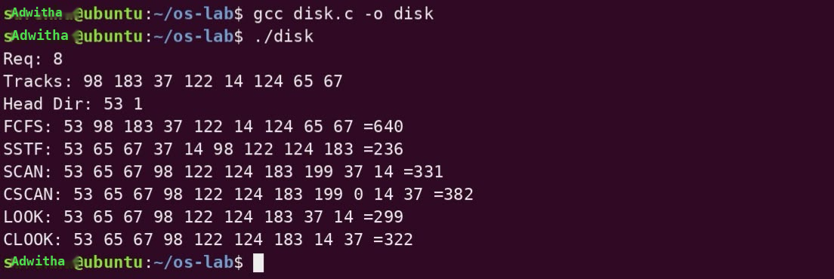

Definitions:
Disk Scheduling
Disk scheduling is a technique used by the operating system to determine the order in which disk I/O requests are serviced.
The main objective is to reduce disk head movement and seek time, thereby improving disk performance and response time.
1. FCFS (First Come First Serve): Disk requests are serviced in the order in which they arrive.
2. SSTF (Shortest Seek Time First): The request closest to the current head position is serviced first.
3. SCAN (Elevator Algorithm): The disk head moves in one direction, servicing requests along the way, reaches the end, and then reverses direction.
4. C-SCAN (Circular SCAN): The disk head services requests in one direction only. After reaching the end, it returns to the beginning without servicing requests on the return journey.
5. LOOK: The disk head moves in one direction until the last request in that direction is serviced, then reverses without going to the physical end of the disk.
6. C-LOOK: The disk head services requests in one direction until the last request, then jumps to the first pending request at the opposite end and continues in the same direction.
Domain and use case: CCTV Storage System

Result : Successfully implemented various types of Disk Scheduling Algorithms.

EX: NO: 14 Sequential and Indexed File Allocation
Aim: To implement and study Sequential and Indexed File Allocation
PART A Sequential file allocation
Algorithm:
START
READ total number of disk blocks n
READ number of files f
INITIALIZE all disk blocks as free
FOR each file i
READ file size
FOR each possible starting block j
CHECK whether size consecutive blocks are free
IF all required blocks are free
start = j
BREAK
END IF
END FOR
IF contiguous space is found
ALLOCATE consecutive blocks to the file
DISPLAY allocated block range
ELSE
DISPLAY "Not enough contiguous space"
END IF
END FOR
STOP

Program:
#include <stdio.h>
int main() {
int n, f, i, j, k, size, start, disk[50] = {0};
printf("Enter total disk blocks: "); scanf("%d", &n);
printf("Enter number of files: "); scanf("%d", &f);
for(i = 0; i < f; i++) {
printf("Enter size of File %d: ", i+1);
scanf("%d", &size);
for(j = 0; j <= n-size; j++) {
for(k = j; k < j+size; k++)
if(disk[k]) break;
if(k == j+size) { start = j; break; }
}
if(k == j+size) {
for(k = start; k < start+size; k++) disk[k] = i+1;
printf("File %d allocated: Blocks %d to %d\n", i+1, start, start+size-1);
} else
printf("File %d: Not enough contiguous space\n", i+1);
}
}
Program output: 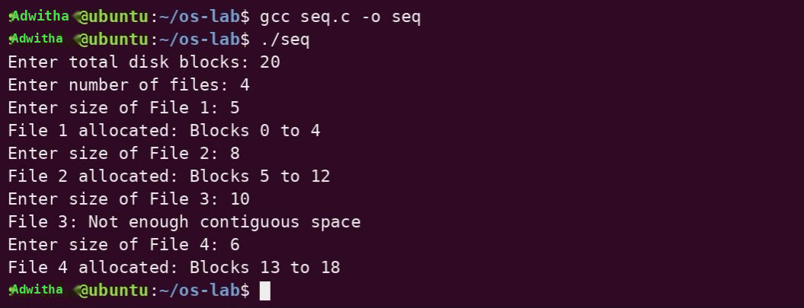

PART B Index file allocation
Algorithm:
START
READ total disk blocks n
READ number of files f
INITIALIZE all disk blocks as free
FOR each file i
READ file size
READ index block
IF index block is invalid or occupied
DISPLAY "Invalid or occupied index block"
CONTINUE
END IF
MARK index block as occupied
DISPLAY index block
FOR j = 0 to size-1
DISPLAY data block
END FOR
DISPLAY file allocation details
END FOR
STOP

Program:
#include <stdio.h>
int main() {
int n, f, i, j, size, index, disk[50] = {0};
printf("Enter total disk blocks: "); scanf("%d", &n);
printf("Enter number of files: "); scanf("%d", &f);
for(i = 0; i < f; i++) {
printf("Enter size of File %d: ", i+1);
scanf("%d", &size);
printf("Enter index block for File %d: ", i+1);
scanf("%d", &index);
if(index >= n || disk[index] != 0) {
printf("File %d: Invalid or occupied index block\n", i+1);
continue;
}
disk[index] = i+1;
printf("File %d allocated\n", i+1);
printf("Index Block: %d\n", index);
printf("Data Blocks: ");
for(j = 0; j < size; j++)
printf("%d ", (index + j + 1) % n); // simple sequential data blocks
printf("\n");
}
}
Program output: 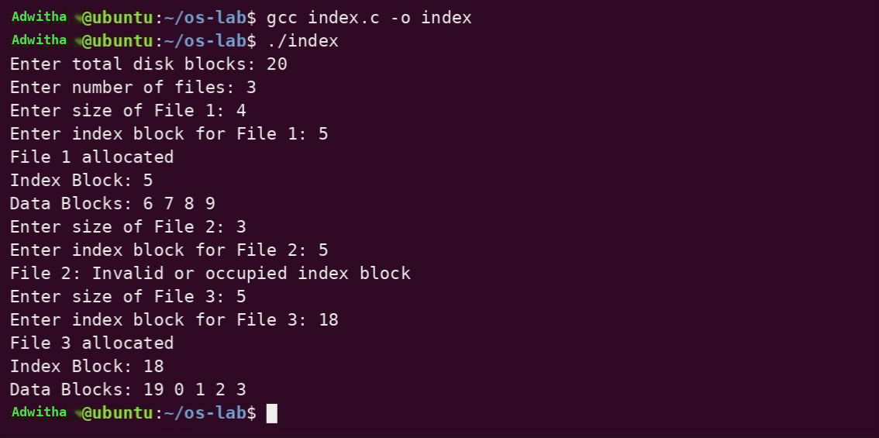
Definitions:
File allocation:
File allocation is an operating system method used to determine how the blocks of a file are stored and accessed on a disk. It helps the OS efficiently manage storage space and retrieve files.

Sequential File Allocation: In this method, the blocks of a file are stored in consecutive disk locations. Since the blocks are adjacent, files can be accessed quickly, especially for sequential reading. However, finding a sufficiently large continuous space for a new or growing file can be difficult, and it may lead to external fragmentation.

Indexed File Allocation: In this method, an index block is maintained for each file. The index block contains the addresses of all the disk blocks occupied by that file. Therefore, the file blocks do not need to be stored consecutively. It supports direct access and makes file storage more flexible, but additional space is required for the index block.

Domain and use case: Video Streaming Application

Result : Successfully implemented and studied Sequential and Indexed File Allocation.

EX NO 15: File organization schemes for single level and two level directory
Aim :To implement and study file organization schemes for single and two level directory
PART A: Single level directory
Algorithm
BEGIN
READ n
CREATE files[20][20], name[20]
FOR i = 0 to n-1 DO
READ files[i]
END FOR
READ name
// Check for duplicate
FOR i = 0 to n-1 DO
IF strcmp(files[i], name) == 0 THEN
PRINT "File already exists"
RETURN
END IF
END FOR
// Create new file
strcpy(files[n], name)
PRINT "File created successfully"
END
Program
#include <stdio.h>
#include <string.h>
int main() {
int n,i;
char files[20][20], name[20];
printf("Enter number of files: "); scanf("%d",&n);
for(i=0;i<n;i++) scanf("%s",files[i]);
printf("Enter new file name: "); scanf("%s",name);
for(i=0;i<n;i++)
if(strcmp(files[i],name)==0) {
printf("File already exists\n"); return 0;
}
strcpy(files[n],name);
printf("File created successfully\n");
return 0;
}
Program output: 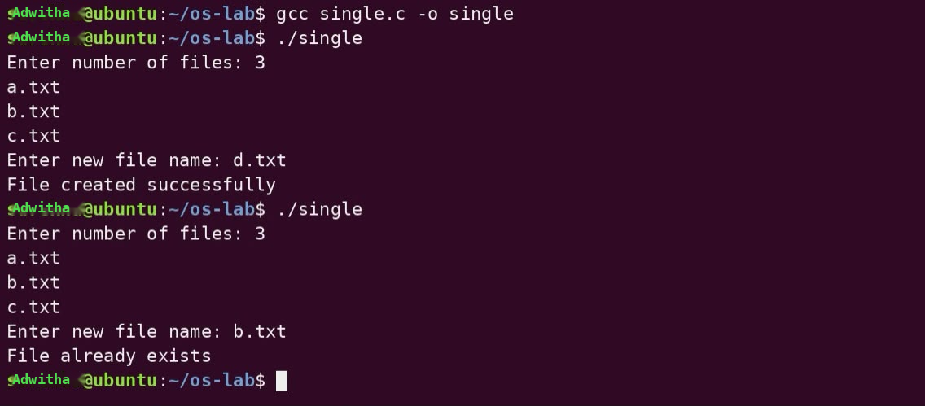

PART B: Two level directory
Algorithm
BEGIN
READ n
CREATE user[20][20], file[20][20], u[20], f[20]
FOR i = 0 to n-1 DO
READ user[i], file[i]
END FOR
READ u, f

// Check for duplicate user-file pair
FOR i = 0 to n-1 DO
IF strcmp(user[i], u) == 0 AND strcmp(file[i], f) == 0 THEN
PRINT "File already exists"
RETURN
END IF
END FOR
PRINT "File created successfully"
END
Program
#include <stdio.h>
#include <string.h>
int main() {
int n,i;
char user[20][20],file[20][20],u[20],f[20];
printf("Enter number of files: "); scanf("%d",&n);
for(i=0;i<n;i++) scanf("%s %s",user[i],file[i]);
printf("Enter student and file: "); scanf("%s %s",u,f);
for(i=0;i<n;i++)
if(strcmp(user[i],u)==0 && strcmp(file[i],f)==0) {
printf("File already exists\n"); return 0;
}
printf("File created successfully\n");
return 0;
}
Program output : 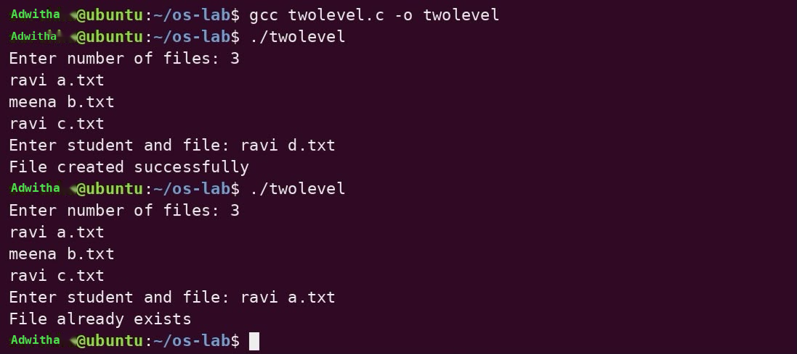

Definitions
A directory is a structure maintained by the operating system to organize and manage files. File organization schemes define how files are grouped and accessed within directories.
Single-Level Directory: In this scheme, all files are stored in a single directory. It is simple and easy to manage, but file-name conflicts can occur when multiple users have files with the same name. It is suitable for a single-user system, such as a simple text editor where one user stores all their documents in one folder.
Two-Level Directory: In this scheme, a main directory contains separate directories for individual users. Each user can maintain their own files, and the same file name can be used by different users without conflict. It provides better organization and privacy compared with a single-level directory.
Domain and use case: College LMS Assignment Submission System
Result : Successfully implemented file organization schemes for single level and two level directory.

